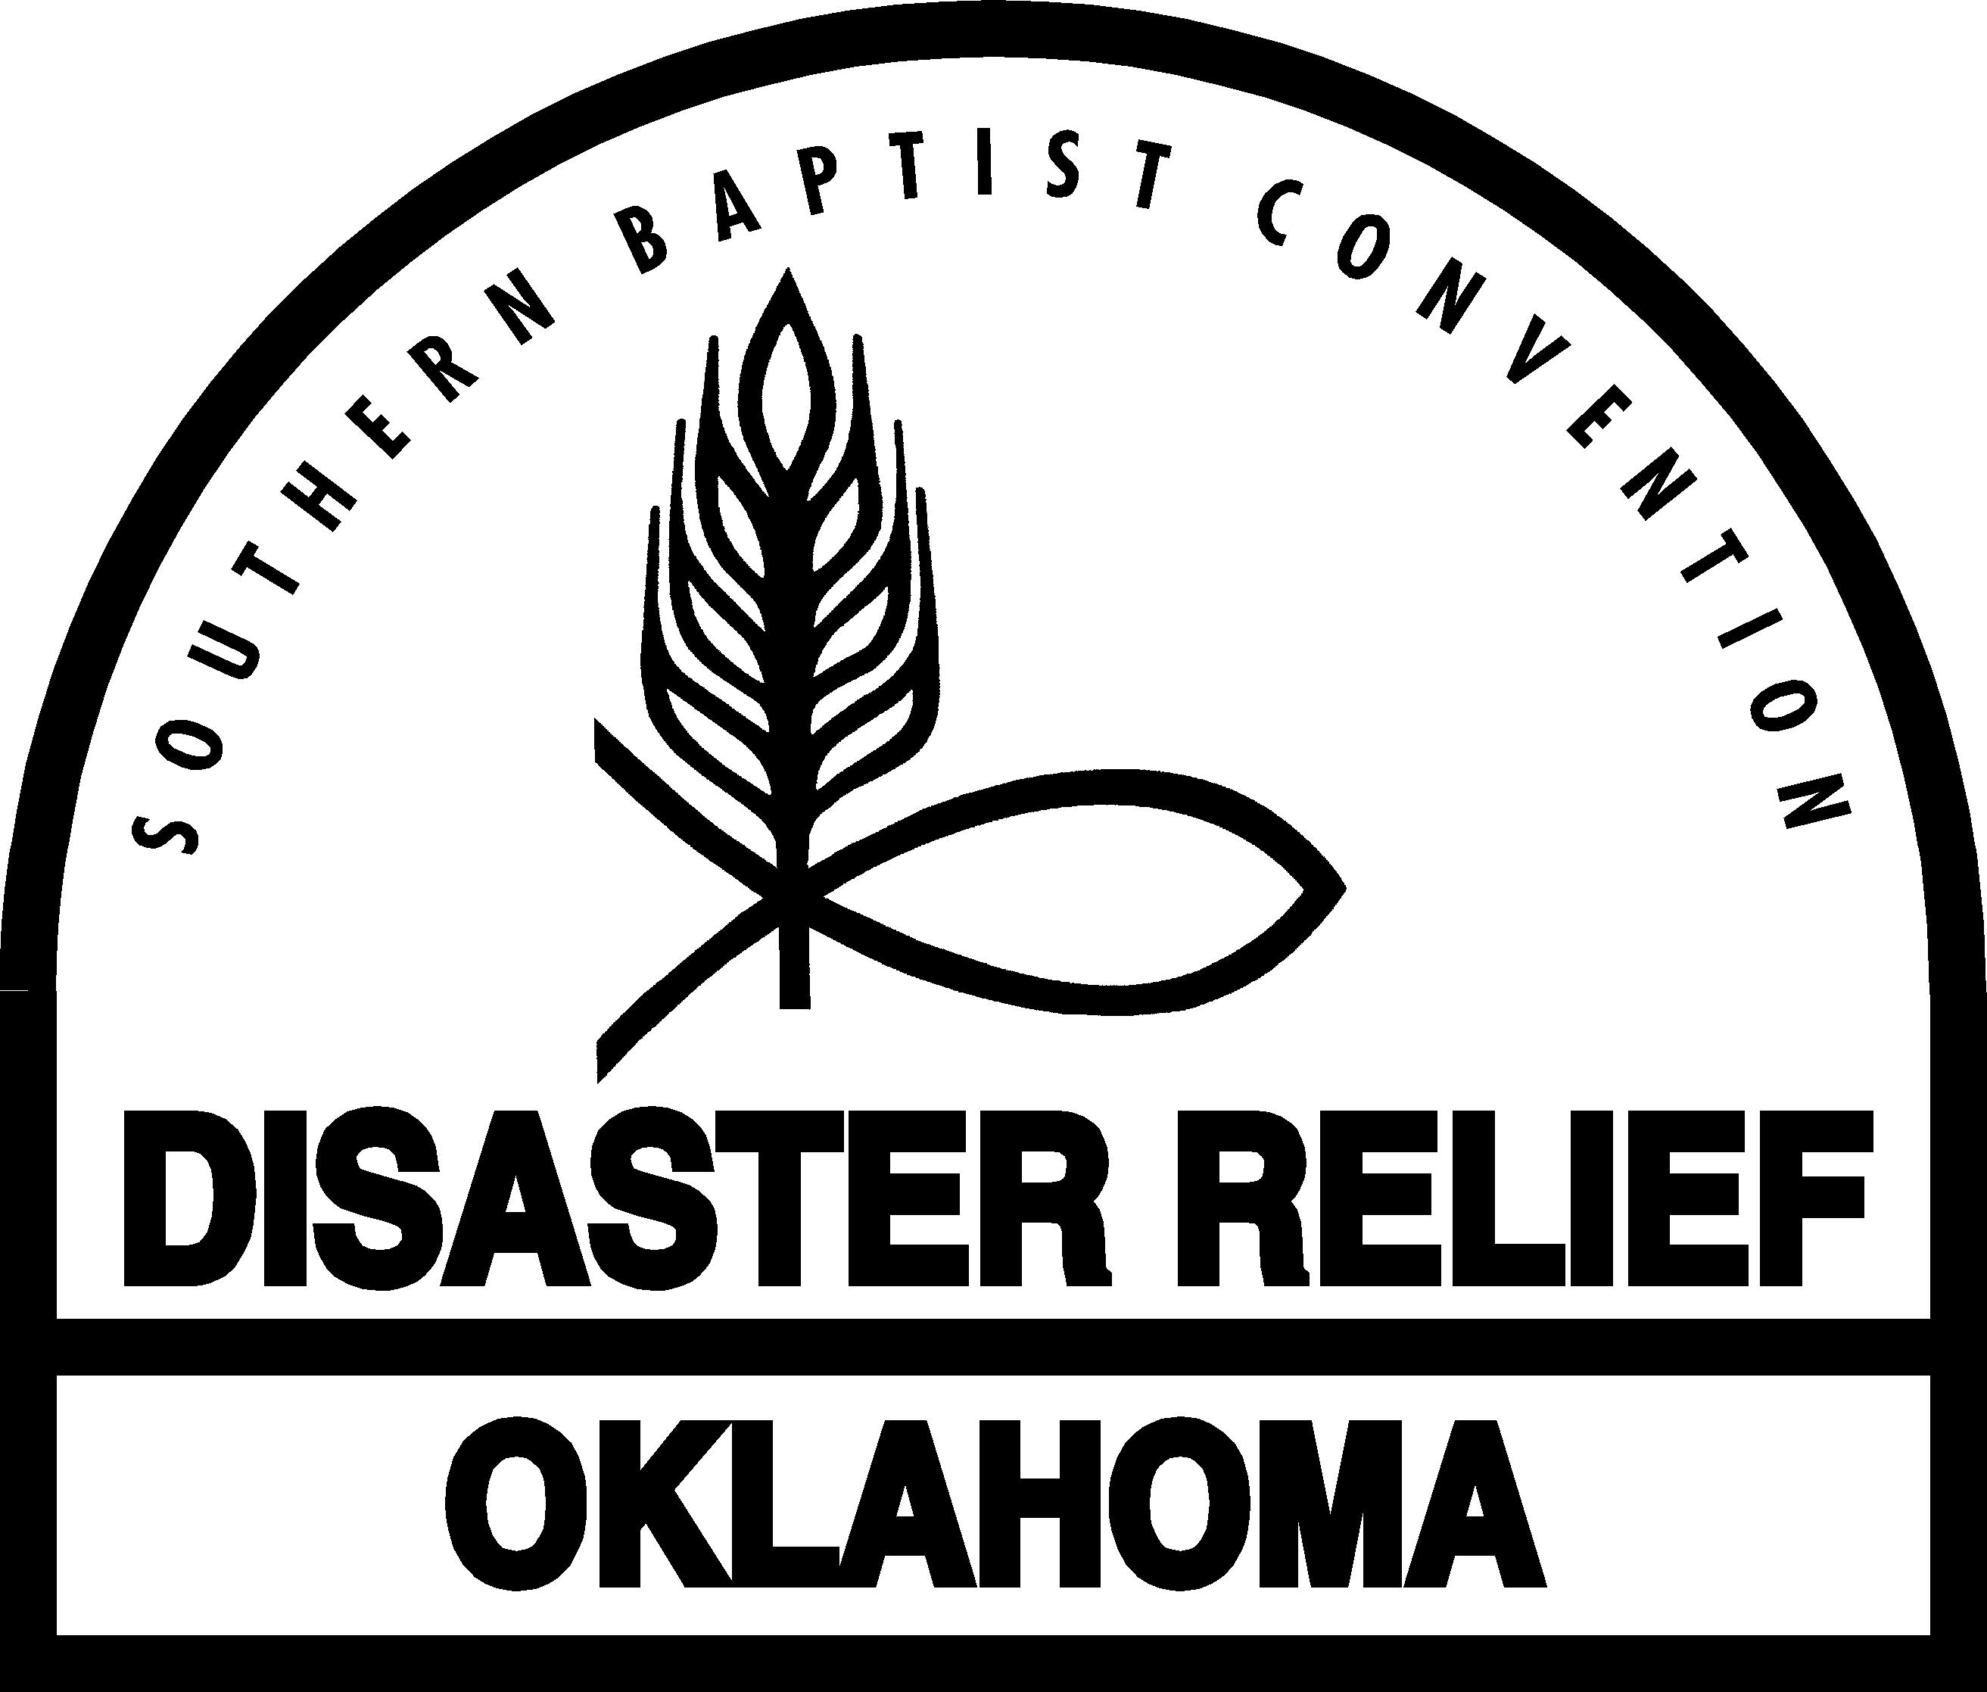
Safety Checklist for All Disaster Relief Volunteers

◻ Be safety-aware at all times. Protect your health and safety as a team member and the health and safety of victims, co-workers and all other persons while en-route to or from, and while at the disaster site.

◻ Be prepared to work safely. Know your assigned position and be sure you have received the training required to perform it safely. If you are unsure ask your Blue Cap before attempting the task. Participate in your team’s practice exercises.

◻ Respect your limitations. Inform your Blue Cap about any health or physical limitations to be considered in your work assignments. If you become unusually tired or experience any other health issue notify your Blue Cap.

◻ Safeguard against worksite hazards. Assist your Blue Cap in inspecting each new worksite or situation for hazards. Follow your Blue Cap’s safety instructions including the locations of safety zones and escape routes.

◻ Rely on standard procedures and equipment. Use the work and safety practices recommended in the Disaster Relief Manual for your position. Avoid short-cuts.
Wear the clothing and use the personal protective equipment recommended in the Manual.

◻ Respect dangers of tools and equipment. Use only the equipment and tools that you are trained and authorized to use. Regularly inspect all vehicles, trailers, equipment and tools for unsafe conditions; notify your Blue Cap about any unsafe conditions.

◻ Carry out the duties of your position. The safety of other team members depends on the job you do.

◻ Communicate effectively. If you are not certain about what you are being told, persist until you are sure. Keep open lines of communication between you and your Blue Cap and with other team members.

◻ Be vigilant. Incidents can happen quickly. If you see a dangerous situation developing speak up and warn other team members. Always put safety above other considerations.

◻ Help reinforce safety on your team. Take an active part in safety meetings.

◻ Report incidents. Notify your Blue Cap if you experience or observe an accident, injury, illness or incident, or any suspicious activity, threat, or other like act.

2-4-23

