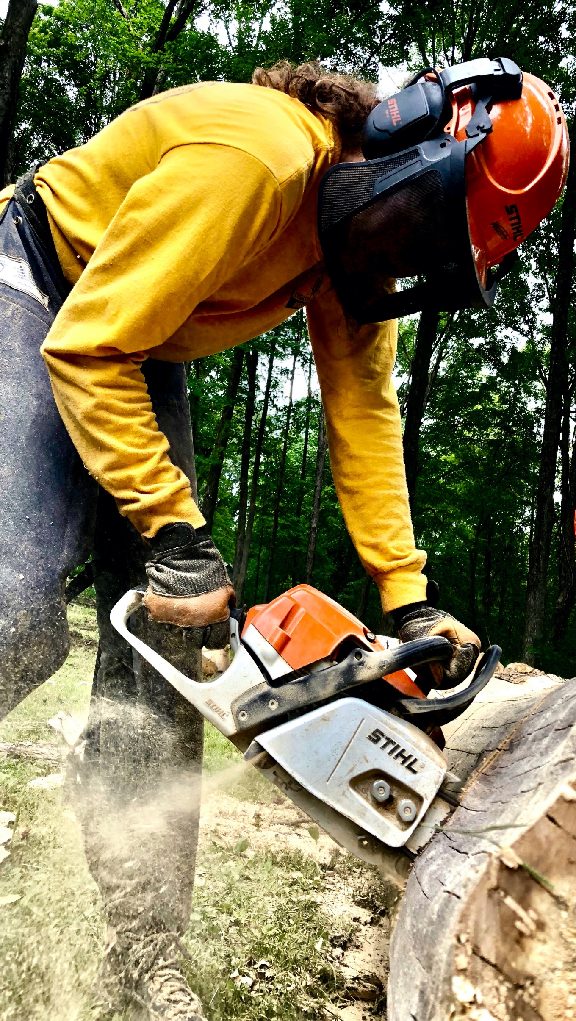
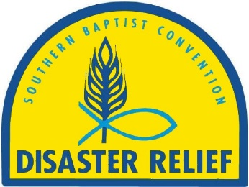
Introduction to
Southern Baptist Disaster Relief

A Christ-centered ministry of the local church, through associational, state, and national partnerships.

“Bringing Help, Hope, and Healing”

2023
TABLE OF CONTENTS:

Introduction…………………………………………………………………………………………………………………... | 4
Chapter One: Who We Are
- Our Motto, Motivation, Mission, Vision, Values………………………………………………………............... | 5
- Personal Responsibility Strengthens Organizational Integrity………………………………………………… | 6
- Our History is Important…………………………………………………………………………………………… | 7
Chapter Two: What We Do
- We Bring Help, Hope, and Healing………………………………………………………………………………. | 8
- SBDR Definition of a Disaster…………………………………………………………………………………….. | 9
- How We Classify Disasters……………………………………………………………………………………….. | 10
- Phases of a Disaster Response………………………………………………………………………………….. | 11
- Types of SBDR Services………………………………………………………………………………………….. | 12
- Levels of SBDR Response………………………………………………………………………………………... | 13
Chapter Three: How We Do It
- We Train…………………………………………………………………………………………………………….. | 15
- We Plan……………………………………………………………………………………………………………... | 15
- We Partner………………………………………………………………………………………………………….. | 15
- We Deploy………………………………………………………………………………………………………….. | 16
- We Organize………………………………………………………………………………………………………... | 15
- Job Descriptions of SBDR Team Members……………………………………………………………………... | 15
- SBDR Organizational Chart ……………………………………………………………………………………… | 16
- Chain of Command …………………………………………………………………………….…………………. | 16
- We Deploy……………………...…………………………………………………………………………………... | 16
- Ethical Guidelines for Disaster Relief Volunteers……………………………………….……………………... | 17
- Stages of Notification…..……...………………………………………………………………………………….. | 18
- We Evaluate………………………………………………………………………………………………………… | 19
- We Debrief………………………………………………………………………………………………………….. | 19
Chapter Four: Deeper Dynamics
- Types of Survivors…………………………………………………………………………………………………. | 20
- Phases of Emotions in a Disaster Relief Response……………………………………………………………. | 21
- Physical Effects of Disaster……………………………………………………………………………………….. | 22
- Disaster Related Stress…………………………………………………………………………………………… | 22
- What Disaster Relief Volunteers Can Do………………………………………………………………………... | 22
- Survivor Reactions at Three Stages of Response……………………………………………………………... | 23

Appendices
- ONE: Personal and Medical Information Form for Volunteers………………………………………………... | 25
- TWO: Release and Indemnity Agreement ……..………………………………………………………………. | 26
- THREE: Volunteer Skills Survey Director…………………………………………………….…………………. | 27
- FOUR: Volunteer Agreement with State Convention Disaster Relief …………………………...…………... | 28
- FIVE: Deployment Checklist (What to Take)……………………………………………………………………. | 29
- SIX: Responding SBDR Team Standard Operating Procedures for Travel…………………………………. | 30
- SEVEN: Abbreviations, Acronyms, and Definitions……………………………………………………………. | 31

This manual was updated June 2023.

Southern Baptist Disaster Relief

All Scripture quotations are taken from the Christian Standard Bible unless otherwise noted. Copyright © 2017 by Holman Bible Publishers. Used by permission. Christian Standard Bible®, and CSB® are federally registered trademarks of Holman Bible Publishers, all rights reserved.

INTRODUCTION:
Welcome! You are about to embark on an adventure which has the potential to change your life. From its beginnings to the well-developed organization of today, Southern Baptist Disaster Relief (SBDR) continues to touch the lives of thousands of disaster survivors and volunteers. It is a biblically based ministry driven by the love of Jesus welling up and overflowing through the lives of our volunteers. We are excited you want to join our family of highly motivated and trained volunteers.

The apostle, John, challenged us to consider the call of this ministry upon our lives, “If anyone has this world’s goods and sees a fellow believer in need but withholds compassion from him—how does God’s love reside in him?” (1 John 3:17) and Hebrews 10:24 says, “And let us watch out for one another to provoke love and good works . . .”

This manual will give you an introduction of who we are, why we do what we do, and how we do it. It is life-changing when a disciple of Jesus discovers the gospel can be shared so easily when human needs are being met. SBDR strives to meet needs and tell people about the hope within us.

This ministry will always remain connected to Jesus and His Kingdom purpose. Through our work, we want people to know Jesus and follow Him. Many disaster relief organizations serve only humanitarian purposes, but SBDR does much more. We are compelled by Christ’s love for all humanity AND His desire that no one should perish. We keep our focus by nurturing our individual relationship with Jesus Christ in the context of a local body of believers who recognize and call out our giftedness in service to God and our neighbors.

We acknowledge our labor is vanity apart from Christ. As Titus 3:14 says, “Let our people learn to devote themselves to good works for pressing needs, so that they will not be unfruitful.” Our fruitfulness is dependent on our connectedness to the True Vine. For us, the work of disaster relief is fruit of our glorious relationship with Christ. We want everyone to see this and give God the glory.

Our world continues to experience devastation and destruction. Man-made events and “acts of God” often lead people to ask “Why?” The truth is God does not expect us to figure out why things happen the way they do nor who or what is to blame. But a better question might be, “What?” What can I do?

Southern Baptist volunteers are preparing themselves to assist during a crisis event. Southern Baptist churches, associations, and state conventions are, even now, working together to build relationships, developing an amazing and comprehensive plan to deploy and manage incredible numbers of volunteers, and providing significant amounts of money and other resources for our crisis response. SBDR quickly deploys trained and experienced volunteers to the point of need and provide logistical support.

The ever-morphing landscape of volunteer disaster response demands we adjust quickly and train our volunteers accordingly. Every disaster requires us to make adjustments in preparation for the next response. By requiring our volunteers to attend training at a minimum of every 3 years we are able to not only communicate the appropriate changes throughout our organization but also evaluate and adjust procedures to improve our organization.

For SBDR, we will remain steadfast in our call from Christ to love our neighbor. How can we continue to provide an effective, efficient, and loving response?

Through you as a trained volunteer who is prepared to respond, no matter what the need, with the best equipment available, the materials and supplies to do the job, the knowledge to respond safely, and the motivation to serve in Jesus’ name. So, we need you! Thank you for joining with other trained disaster relief volunteers who stand ready to serve. May God bless you as you prepare to bring Help, Hope and Healing to those who are hurting.
Chapter One: Who we are
Southern Baptist Disaster Relief (SBDR) is a cooperative effort between prepared and highly motivated church members from 42 state conventions, the Canadian Baptist Convention, and Send Relief, Inc. to deliver the Gospel message of Jesus Christ through the ministry of disaster relief. Send Relief, a collaboration between the International Mission Board and the North American Mission Board, shares practical help and the hope of Christ while meeting human needs across the globe through compassion ministry.

Our MOTTO: “Bringing Help, Hope, and Healing.”

Our MOTIVATION can be summed up in one phrase: “A cup of cold water in Jesus’ name” (Matthew 10:42). There is no one who needs “something else to do” as many of us are overcommitted in our schedules. However, the motivation for serving others and obeying the Great Commission to “go” comes from the Scriptures and our experience of faith in Christ. How can we not go?

- We are motivated by the commands and compassion of Christ (2 Corinthians 5:14).
- Jesus communicated through His words and deeds (Luke 24:19)
- He values people in crisis (Matthew 9:36).
- In Luke 19:10, Jesus speaks of His mission to seek and to save the lost. It is a word picture describing Jesus’ desire to go to the ends of the earth in order to save people facing an eternal crisis, the ultimate disaster.
- In Luke 10:25-37 and Matthew 22:37-40, Jesus defines our neighbor as anyone in crisis and further states that the authenticity of our relationship with God is tied to caring for our neighbor.
- In Matthew 25:32-46, Jesus establishes our demonstration of His compassion for people in crisis is the standard by which all followers of Christ will be measured.
- Disaster relief is meeting needs in a timely response with loving care:
  - James 2:15-16 shows meeting human needs is a faith lived out.
  - Acts 2:45 shows meeting human needs is to be a cooperative effort.
  - Luke 9:2-6 shows meeting human needs is a companion calling to the proclamation of the Gospel.

Our MISSION
SBDR is a Christian network bringing help, hope, and healing to people in crisis.

Our VISION
We envision all SBC life engaged in disaster relief through the church, in the community, and for the gospel.

Our VALUES
These core values are the foundation for the ministry of SBDR. They comprise the constant guide by which we perform disaster relief ministry and interact with an affected community, our partners, other organizations, volunteers, and Southern Baptist constituents.

Christ-centered
SBDR is comprised of individuals who are believers in Jesus Christ. Volunteers are under the imperative to minister to people and demonstrate God’s love as they share the message of hope in Jesus Christ.

This is how we have come to know love: He laid down his life for us. We should also lay down our lives for our brothers and sisters. If anyone has this world’s goods and sees a fellow believer in need but withholds compassion from him—how does God’s love reside in him? (1 John 3:16-17)

What would this Christ-centered life look like in your ministry with SBDR?
- You are consistent in your faith – even when you are not on a disaster response.
- You are active and involved in your local church.
- You have a Christ-like relationship with your family and church.
- You maintain a steady diet of scripture.
- Your character is growing in conformity with Christ’s: being patient and caring, possessing a spirit of love, and desiring to see others saved.
- You are prepared to use every opportunity to share your faith in Christ.

Partnership Oriented
SBDR seeks to be a valuable partner, building strong biblical relationships which empower leaders, volunteers, and partners to serve communities affected by disaster with passion, integrity, professionalism, and credibility.

Always praying with joy for all of you in my every prayer, because of your partnership in the gospel from the first day until now. I am sure of this, that he who started a good work in you will carry it on to completion until the day of Christ Jesus. (Philippians 1:4-6)

Adaptive in Practice
SBDR adapts to becoming the hands and feet of Jesus in times of disaster while maintaining a commitment to our mission, vision, and values.

…we endure everything so that we will not hinder the gospel of Christ. . . . To the weak I became weak, in order to win the weak. I have become all things to all people, so that I may by every possible means save some. (1 Corinthians 9:12c, 22)

Effective in Action
SBDR empowers leaders, volunteers and partners through training, mentoring, accountability, and structure. In this way SBDR enables them to use their skills, talents, abilities, and resources to be effective followers of Christ ministering to others affected by disaster.

Just as each one has received a gift, use it to serve others, as good stewards of the varied grace of God. (1 Peter 4:10)

Local Church Focused
SBDR maintains a strategic and intentional partnership with local churches to support, reinforce, and encourage their ministry of making disciples of Jesus Christ and growing the Kingdom of God.

Now to him who is able to do above and beyond all that we ask or think according to the power that works in us— to him be glory in the church and in Christ Jesus to all generations, forever and ever. Amen. (Ephesians 3:20-21)

Does my personal responsibility strengthen our organizational integrity?

A volunteer needs a positive mental, social, and spiritual attitude to take on the task of providing physical assistance. As a volunteer, you have the responsibility for your own personal preparation, motivation, attitude, availability, participation, training, and improvement.

Ask these questions of yourself:
- Do I have a servant’s heart or am I thinking about myself much of the time?
- Am I willing to take directions from others or am I resentful of demands made on me?
- Am I able to adapt to ever-changing circumstances or do I become frustrated when things change?
- Do I know how to be part of the team, or do I need to be in charge?
- Am I going to help people in need, or do I have a personal agenda?
- Am I willing to work wherever needed or am I inflexible?
- Am I self-controlled in speech, attitude, and actions?
- Am I physically strong enough to work long and strenuous days?

Prayerfully consider if the Lord is leading you to serve in this ministry.

Why is it important to learn from our history?

Since 1967, SBDR traces its beginning when a few Royal Ambassador (RA) leaders took some RA boys to respond to a Texas hurricane. So, it is appropriate the SBDR logo borrowed the blue and gold color scheme from the rich symbolism of the Royal Ambassador shield:
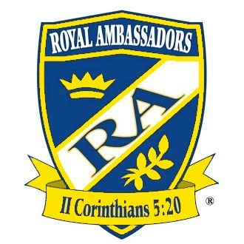

- Blue represents the volunteer’s loyalty to Christ which governs our actions and relationships.
- Gold represents the worth of every person to Christ.
    - Arch of the Southern Baptist Convention is the umbrella of the SBDR world-wide cooperative network.
- Wheat symbolizes physical help.
- Fish symbolizes spiritual help.
- Name below the logo identifies the Baptist state convention being represented.

Credentialed team members are urged to wear disaster relief (DR) apparel during a disaster relief response or disaster relief functions, such as training, promotion, and conferences related to SBDR. Upon becoming inactive, SBDR volunteers should check with their convention DR director on how to properly repurpose their DR apparel.

As Lloyd Jackson of Virginia stated, “Disaster relief provides a unique opportunity to translate the message and person of Jesus Christ into flesh and blood as His followers respond in love and compassion to hurting people regardless of circumstances, social status, financial situation, language, political persuasion, theological stance, education or race. ‘As you do unto these, you do unto me’ remains the guideline for ministry to people in and through disaster relief.” To God be the glory!

Chapter Two: What we do
We Bring Help
When disasters happen, people and communities find themselves in immediate need of basic necessities: food, water, shelter, electricity, and fuel, etc. Our network of volunteers and equipment make it possible for SBDR to quickly respond anywhere in the United States and in many places around the world.

We are known for our mass feeding capabilities; however, we have added other ministries including but not limited to: flood recovery, chainsaw recovery, fire recovery, temporary roofing, chaplaincy, shower, laundry, childcare, communications, power generation, water purification, and more.

We Bring Hope
There are two kinds of hope. The first is illustrated by the following quote:

[A substantial percentage] of those impacted by disaster find their usual coping mechanisms have failed and find themselves suffering significant distress. While their immediate life needs may have been met, they still cannot see a better tomorrow; they have no hope that things will get any better. (Pastoral Crisis Intervention 2002 International Critical Incident Stress Foundation, Inc.)

Situational hope is being able to see a way forward. All they can see in front of them is a mountain without a way around it. As a disaster relief volunteer, you may be able to offer them the hope of a way around the mountain.

Relational hope is present regardless of a person’s situation because it rests on the person and work of Jesus Christ. In Jesus Christ, hope is eternal. As a SBDR volunteer, you are a messenger of good news and the bearer of a relational hope through Jesus Christ.

As Colossians 1:27 says, “God wanted to make known among the Gentiles the glorious wealth of this mystery, which is Christ in you, the hope of glory.” Be ready. The act of bringing help may open the door to share the hope of eternal life through Jesus Christ. Ministry may prepare the soil for the planting of the seed of the gospel. This is our greatest work because it leads to eternal results. Be prepared to answer the question “How much does this work cost?” with “The price has already been paid . . .”

We Bring Healing
Just the simple act of listening to those who are affected by disaster initiates the healing process. In most cases, the survivor’s greatest need is having someone listen to their story. LISTEN to their story.

When we arrive with a feeding unit, a team of smiling volunteers who bring words of hope along with a nutritional meal, survivors get the feeling someone cares; they will not have to wonder about their next meal. When a family whose home and possessions have been destroyed by flood, wind, or fire sees a team of caring people in gold hats and shirts removing mountains of debris, they begin to see the possibilities for a new beginning. Suddenly, what seemed hopeless and impossible starts looking like a plan with a purpose. And most importantly, the question “Where is God when I need Him?” is transformed into belief, “God is here, and He cares for me.”

It is not unusual for our presence to be a catalyst for reconciliation between neighbors and family members. Nor is it strange for us to help survivors become factors in their own recovery. When our volunteers bring their knowledge and experience to the disaster, they can ease tension and stress by helping individuals and communities align their expectations with reality. Regardless of the form healing takes, it is inspiring to remember in every town Jesus visited, He left many healed people in His wake.

How We Classify Disasters:
SBDR Definition of Disaster:

An occurrence that causes human suffering or creates human needs that the survivors cannot alleviate without assistance.

Types of disasters:

- Blizzard
- Boat Accident
- Bombing
- Bridge Collapse
- Chemical Spill
- Crash
- Drought
- Drowning
- Earthquake
- Explosion
- Famine
- Fire
- Flood
- High Wind
- Highway Accident
- Hurricane
- Ice Storm
- Industrial Accident
- Natural Gas Accident
- Nuclear Accident
- Pandemic
- Power Failure
- Riot
- Terrorist Attack
- Tidal Wave
- Tornado
- Transportation Accident
- Typhoon

Natural / Man-Made Disasters:
- Natural disasters include tornadoes, hurricanes, ice, wind, earthquakes – any crisis event due to weather conditions.
- Man-made disasters can be of major consequence as well – fires, riots, explosions, train derailments, terrorist attacks, war, pandemic, and more.

Primary / Secondary Disasters:
The initial event or impact. A secondary disaster is a consequence of the original occurrence. Earthquakes, tornadoes, floods, snowstorm may trigger secondary disasters such a tidal wave, power failures, dam failures, floods, fires, or more.

Extent of Destruction:
Regardless of the area affected, the duration of the event and reconstruction can help classify disasters as local, widespread, or catastrophic. Although a single-family fire is tragic to those involved, widespread damage or catastrophic will determine the amount of response needed.
Phases of Disaster Response:
Based on reaction time and length of response.

Readiness: Begins now: be alert and be available. Proper training and personal preparation are vital to the success of the mission. Demonstrate consistent spiritual preparation. Be ready not only when a disaster strikes, but more importantly, when God sends.

Response: The immediate response to a disaster usually begins within the first 24-48 hours and can last several weeks. Emergency relief is provided such as feeding, shelter, childcare, chaplaincy, and immediate needs.

Recovery: This is a key role for SBDR response. This phase can last a few days to a few months. Help is provided to get people back to some normalcy. Resources provided may include chainsaw, flood recovery, fire clean up, chaplaincy, temporary roofing, etc.

Rebuild: this phase is more long-term and can last a few months to several years. It takes many resources, volunteers and emotional support. There are many aspects to rebuild including financial aid, reconstruction, rebuild, volunteer management, continued debris removal, etc.
Types of SBDR Services
Airlift Kitchens | Airlifting kitchen equipment, supplies, and volunteers overseas and setting them up for food preparation in a disaster area.
Asset Protection | Watching and patrolling SBDR sites and equipment.
Chainsaw | Clearing trees and other major obstructions following wind and flood events.
Chaplaincy | Disaster chaplains who provide crisis intervention and spiritual care for individuals throughout the disaster cycle.
Childcare | Providing temporary childcare through a mobile unit or at fixed location such as a church or school.
Communication | Volunteers who provide communication capabilities during disaster relief responses.
Damage Assessment | The preliminary assessment of the disaster including extent of damage, meeting homeowners and assessing damage to homes, and providing resources as needed.
Feeding | Food preparation and distribution from a mobile unit or a fixed location such as a church or school.
Fire Recovery | Involves sifting and/or removing ash and debris with proper disposal and recovering personal property.
Flood Recovery | Involves removal of contaminated belongings and dwelling components; includes washing and sanitizing affected areas.
Heavy Equipment | Heavy equipment to support disaster operations such as forklift, skid steer, man lift, tractors, etc.
Incident Management Team | Directs the SBDR daily operations and provides appropriate leadership for the disaster response
Interpreters | Translating or interpreting regarding disaster assistance.
Medical Support | Provides medical support to the SBDR ministry teams. These individuals often work with a variety of SBDR units.
Rebuild | Rebuild / Repair to homes and churches
Roof Tarping | Covering impaired roof sections with appropriate material and securing it to reduce further damage to the interior of the home.
Transportation | Involves asset and volunteer transport.
Water Purification | Provides large capacity of filtered potable water.
Levels of SBDR Response
From one church member to a national organization, Southern Baptists bring unique skills, preparation, and approaches to disaster relief efforts, always with Christ as the prime example. The Southern Baptist response takes place at seven levels:

Individual or Team: Individual volunteers can provide labor, equipment, or specialized services, such as cleanup or feeding. They provide their own equipment at their own expense and serve in cooperation with the organized disaster relief effort. They may work with or support other groups to provide needed services.

Volunteers can serve as part of a unit which is designed and equipped to provide specialized services in a disaster area. These units may be self-contained (e.g., feeding unit or communication unit) or designed for use in another facility (e.g., a childcare unit serving from a church building).

If you would like to be a part of the disaster relief response, you should make your availability known according to the protocols set up by your convention’s DR Director. You must complete the required training to participate with a specialty unit, so you are ready when called to serve. Trained disaster relief volunteers know self-deployment is an unacceptable practice. Volunteers are tremendous assets when deployed properly by your convention DR director.

Individuals are also encouraged to develop a family disaster preparedness plan and supply kit, so you will be prepared to respond to needs within your family and community in the event of a disaster. Ask your convention DR Director for a copy of the Family Preparedness Manual.

Church: Talk with your local church about ways they are already involved or could be involved in disaster relief ministry. Churches have an incredible opportunity to provide friendship, crisis intervention, and encouragement to survivors of disaster. It is best to work in cooperation with your Baptist convention and your local association as there are experienced leaders and resources to help train and equip members of your local church and to assist your church in preparing for disaster relief involvement. After receiving the church’s approval, prepare the church facilities for disaster relief service. A church can provide their facilities and designate space for a specific disaster service, such as a kitchen, a shelter, or storage.

Churches should seek the assistance of the convention DR director, who will be able to provide training and assistance in the development of the church disaster relief plan. Churches are encouraged to develop a church disaster preparedness plan. Ask your convention DR director for a copy of the Church Preparedness Manual.

Association: Associations can coordinate their member churches’ involvement as shelters, feeding units, collection and distribution of food and other commodities, and more

Associations are encouraged to develop an associational disaster preparedness plan. Ask your convention DR director for a copy of the Associational Preparedness Manual.

State Convention: State conventions develop their own disaster relief response plan and training based on the DROP (Disaster Relief Operational Procedures) Manual and the SBDR Framework.

Affected state conventions determine the types of services, equipment, and organization needed for a disaster response. State conventions coordinate church, association, and in-state units/teams when responding to a disaster within their state. Assisting state conventions can also deploy units and personnel in multi-convention, national, and international disasters in response to a request from other convention DR directors or Send Relief.

All enlistment, training, activation, and deployment of volunteers and units are the responsibility of the convention DR director.

Regional: SBDR is also organized geographically across North America into regions. A region is a cluster of state conventions in proximity to one another. When a state’s resources are inadequate to meet the response needs, the affected convention DR director may call upon his/her regional partners for assistance before inviting help from more distant conventions across the country.

National: Send Relief (SR) is a collaboration between the North American Mission Board (NAMB) and International Mission Board (IMB). Send Relief is the North American Mission Board’s compassion ministry arm. Send Relief offers resources, training, and events to help individuals and churches engage in relief work through prayer, giving and service. Opportunities are provided to support foster care and adoption, fight poverty, end human trafficking, help refugees and internationals, and mobilize for crisis response. Send Relief supports SBDR with response resources, shared equipment and equipment rental, marketing and public relations for major disasters, support for untrained volunteers, and strategic development in coordination with SBDR leadership.

International: Send Relief (SR) is a collaboration between the North American Mission Board (NAMB) and International Mission Board (IMB). Send Relief is the International Mission Board’s compassion arm and is responsible for international disaster relief and community development. Project requests and funds for disaster responses outside of the United States is coordinated by Send Relief. The Send Relief Crisis Response Director provides coordination for international disaster relief response in coordination with Send Relief Area Directors and field partners. Volunteers who respond to international disasters are responsible for providing their own travel and other expenses.

CHAPTER THREE: How we do it

We Train
Experience has shown the need for standard training for disaster relief volunteers. There are some general training requirements for a person to be recognized as an SBDR volunteer.

Disaster relief volunteers must retrain and renew background checks every three years. While there may be some variation from one state convention to another, there is consensus on this point: Retraining helps to ensure our readiness and maintain our integrity as a dependable and trusted partner.

Disaster relief volunteers will find it helpful to participate regularly in disaster relief training. Even if you have already had training, you can help others by sharing your experiences.
- Participate often in disaster relief projects like training, non-disaster operations, maintenance, and renovations.
- Disaster relief volunteers are expected to participate in training events and learn about disaster conditions and how to deal with the situations they will face.
- Disaster relief volunteers must be willing to provide leadership as the need arises and assignments are made.

We Plan
During a disaster, SBDR leadership at every level is engaged in matching the resources with the needs. Information is gathered and evaluated so wise decisions can be made. Logistical support for volunteers (lodging, meals, showers, laundry) will be arranged ahead of their arrival and as assets are en route, they must be tracked. It is common for teams to be given a new destination even while they are on the way because new information leads to adjusted priorities and better efficiency. It is important for trained volunteers to understand the dynamic nature of response planning and practice flexibility. Always, pray for your leaders, be gracious, and trust them.

We Partner
SBDR cooperates with many voluntary organizations, state and local government, emergency management officials, and the Department of Homeland Security. We encourage and assist families and churches to develop a plan of action to minister to their community in the event of a disaster. They also should plan how they will work with others in ministry in the aftermath of a disaster.

We Organize

Job Descriptions for Southern Baptist Disaster Relief Team Members

The following list of job descriptions will help you understand the organization of SBDR. Each person on a unit or team has an important responsibility. Involvement in convention training is the only way to fully understand the organization because every convention is slightly different.
- Convention Disaster Relief Director—The person designated by a convention to develop and implement disaster response for their convention.
- Incident Commander (White Hat)—The person designated by the convention DR director to direct the overall daily operations of the disaster relief response and reports directly to the convention DR director. They will develop command staff and general staff as needed to provide appropriate leadership for the response.
- Incident Management Team (IMT) – The on-site leadership team as constructed by the Incident Commander or convention DR director to manage planning, operations, logistics, and administration for that site. The Incident Commander or White Hat directs the IMT and their work.
- Unit Leader (Blue Hat)—The person designated to direct the overall daily operation of a disaster relief unit or team. Reports directly to the Incident Management Team (IMT).
- Lead Workers—The people designated to direct one part of the daily operation of a disaster relief unit or team for a period of time (e.g., head cook, inventory person, mechanic). Reports directly to their Unit Leader (Blue Hat).
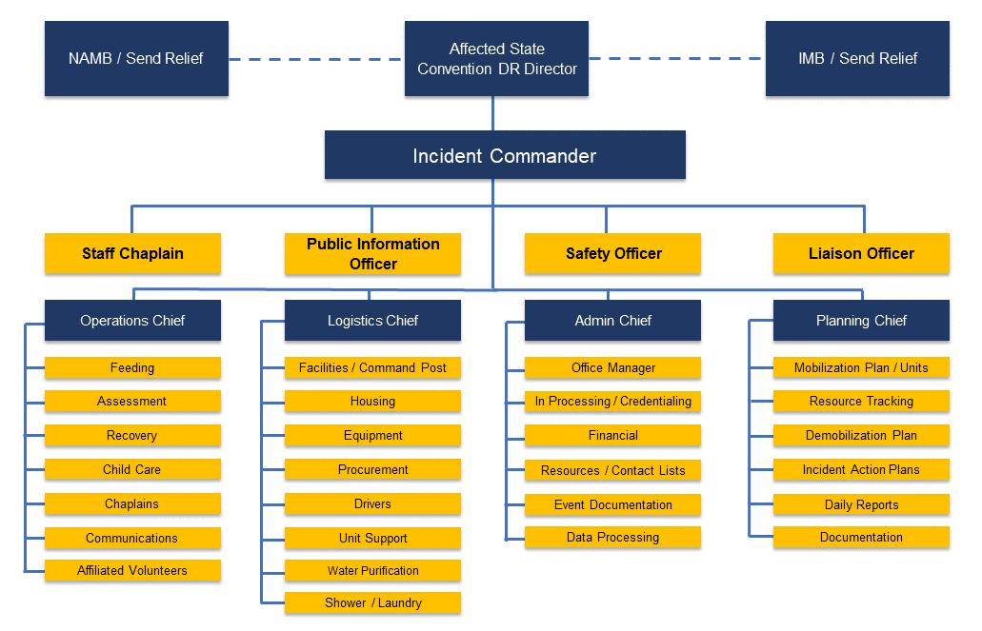
- Credentialed Volunteer (Gold Hat)—A member of a disaster relief unit or team who has completed the minimum required training and background checks. Reports directly to their Unit Leader (Blue Hat).
Chain of Command
In most state conventions, planning and preparation for disaster relief has been assigned to a state convention staff member or designated volunteer. The chain of command for disaster relief responses is reflected in the chart below. As a Gold Hat, all you really need to know is, unless told otherwise, you are report to your Blue Hat.

We Deploy
The following suggestions will assist you in preparing for your involvement in disaster relief.

Health Guidelines
- Stay in good health and good physical condition.
- Have regular physical examinations.
- Consult your physician about your involvement in disaster relief.

Practical Guidelines
- Look over the “Deployment Checklist (What to Take)” (Appendix Five) and secure the basic items.
- Disaster relief volunteers need to arrange evaluate availability.
- If you are employed, discuss your situation with your employer and inquire about volunteerism policies.
- Each volunteer is responsible for their own medical insurance and health coverage in case of accident, injury, or illness.
- For each deployment, volunteers must provide a current up-to-date Medical Release Form for Volunteers (Appendix One) and must complete and sign a Release and Indemnity Agreement which will vary by state (Appendix Four).
- In times of disaster, be proactive and seek deployment information for further details and mobilization instructions. This too will vary by state.
It is important for SBDR volunteers to understand:
- You may not be the first called.
- You may not work with the same people every time.
- Use caution regarding physical or personal needs you are not trained to handle.
- Remember to be adaptable and make adjustments as needed.
- Always understand your limitations.

Volunteers who respond to disasters are responsible for providing their own transportation and related travel expenses to and from the disaster site. Carpooling is encouraged. Typically, meals, lodging, and showers are provided throughout the duration of the response once on site.

SBDR volunteers should be prepared to recognize stress in themselves and others. Disaster response conditions are stressful. Volunteers will often work long hours under difficult conditions. Volunteers should:

- Take medications as prescribed by your physician. If possible, have a backup prescription order for medications.
- Work within your strengths and limitations: physical (strength and health), emotional (stress management), and mental (knowledge and skills).
- Wear clothing, footwear, and special equipment suited to the task and conditions you will face.
- Wear modest, appropriate, and Christ-honoring clothing at all times, day and night, including sleepwear and loungewear. At times, lodging may be co-ed.
- Avoid extended sitting or standing in the same position, constant exposure to the sun, and prolonged exposure to water, heat, and cold.
- Eat regularly and drink plenty of water.
- Rest when you can. Sleeping will be difficult.
- Do not base your workload on another person. Pace yourself.
- Use caution where you may encounter heavy traffic, broken glass, nails, and downed electrical lines.
- Report all injuries to the Unit Leader (Blue Hat). Become familiar with policy and procedures for on-site illnesses and injuries including how and where to get help in an emergency.

Ethical Guidelines for Southern Baptist Disaster Relief Volunteers
- Take care not to damage the group effort by careless words or actions.
- Each person must remember he or she represents the Lord and the church. All attitudes and actions should demonstrate the example of Christ.
- Our policy is to not accept contributions in the field. If they insist, refer them to the unit leader (Blue Hat).
- Be sensitive to the fact that information shared by anyone in confidence should remain so. Respect the privacy of every individual.
- Be sensitive to the people involved. Always ask permission before taking pictures.
- When sharing information, be sure your facts are accurate. Do not participate in spreading rumors which may circulate following a disaster.

Stages of Notification
The first step to activate units and teams begins with the affected state convention placing a call for help. SBDR uses the following process for the activation of units and volunteers. The urgency of some events requires immediate activation of volunteers and material resources.

- There is a possibility of a response
- Can you GO?
- Time to make plans
Alert

- probability of a response
- Will you go and can you commit?
- Be prepared to deploy once instructed
Standby

Closing
GO / NO GO
- The decision is to GO!
- The decision may be NO GO!
- Could revert to Alert, Standby, or Stand down

- Close or demobilization
- Unit is no longer needed
- May relocate or return home

Alert
The first stage of response at any level – local, state, or national, is ALERT. At this point there is simply a possibility of a response. The primary question is, “Can you go?” or “What can you do to make yourself as available as possible?” Depending on your state convention’s protocol, you may or may not be asked for a commitment. If so, it is time to begin making plans.

Standby
The second stage is STANDBY. At this point, there is a probability of a response. Your leaders will be looking for a commitment. The unit/team will depart as soon as it is requested. Prepare all personnel and equipment to leave at a moment’s notice. If the unit/team is not asked to respond, they may revert back to ALERT or be taken off the potential response plan.

Go or No Go
The third stage of response is GO or NO GO. If the decision is no go, the status of the team may revert to STANDBY, ALERT, STAND DOWN, or it may be taken off the response plan entirely. GO means a response is definite and the team will mobilize as directed.

Closing
The final stage of response is CLOSING (or called demobilization). The mobile unit is no longer needed at that location. It may be reassigned to another location or allowed to return home. The decision to close or terminate will be made in collaboration with the affected convention DR director and the Incident Commander.

During the Go or No Go stage is when the convention DR Director activates the convention’s units/teams, determining the number of volunteers needed and giving its members the following essential details:

- Specific circumstances at the disaster location.
- Location and how to get there or to the staging area.
- Specific assignment of service.
- Contact information of person to report to.
- Any other pertinent information available at the time of deployment about the response.

We Evaluate
Effective organizations take great care to evaluate themselves. We evaluate while tasks are being accomplished and again when they are completed.
- Did we meet the physical and spiritual needs? Was there an evangelistic focus?
- Plans were made. (Remember, things do not always go as planned.)
- Systems were created. Did they work?
- Equipment and tools were used. Did they work? Do they need to be repaired or replaced?
- Communication happened. How well?
- Training took place. Did it actually match the task?
- Collaboration took place. Are relationships intact? How can relationships be strengthened?
- What must happen to be prepared for the next response?

Everyone is tired at the end of a response. However, remember to take time to evaluate each response. Seek ways to give your unit leader (Blue Hat) helpful feedback while memories are fresh. Feedback needs to be developed into actions items.

Ideally, everyone is built up when evaluation takes place. However, when things do not go as planned, they too must be addressed. SBDR is strengthened because the internal parts find their place and are strengthened. In the end, our Lord is magnified.

We Debrief
It is important for the health and well-being of all volunteers to participate in debriefing. This is done at various times and in various ways.

- At the beginning of each day as you participate in the morning devotion, sharing, instruction, and prayer time.
- During the day and while working in the field as you talk with fellow volunteers sharing your experience.
- At the end of each day as you participate in the evening devotion, sharing, instruction, and prayer time.
- During times of travel as you visit with others while in the vehicle.
- Upon return home to talk and share of your experience of how God had worked in the lives of those you served as well as what you learned through the experience.

There are at times, seeing such destruction and tragedy, that volunteers will experience emotional stress and need to seek further aid to process those emotions. Seek qualified counselors that can assist you to heal and recover.

CHAPTER FOUR: Deeper Dynamics

Disasters affect people. This chapter will help you as a SBDR care for yourself, your teammates, and the people you are sent to help. You will also gain a deeper understanding of the importance of the work we do.

Types of Survivors
INDIRECT:
Indirect survivors live on the fringe of the disaster area, near those directly impacted. They may have grown up in a home in the impacted area. The indirect survivor may suffer minor inconveniences or guilt feelings over the losses of others while feeling happy that his family was not affected. Early on he or she may take an active role in relief efforts. Or his or her reaction to the disaster may include leaving the area.

Hidden:
Hidden survivors are the disaster relief workers or first responders who could not save everyone or every home. Volunteers tend to be caring people who do not like to see other people hurting, so they take on the burdens of the affected. As they internalize the pain, they may become survivors themselves. Volunteers can avoid this by discussing these feelings during the daily debriefing, with Disaster chaplains or crisis interveners. Operational Stress First Aid (OSFA) is another tool available to volunteers to help one another cope with the stresses of deployment.

Direct:
Direct survivors live in the area affected by the disaster and has suffered losses.

Phases of Emotions in a Disaster Relief Response

Disaster Survivors commonly go through four distinct emotional phases in coping with a disaster.

Heroic
The heroic phase occurs during and immediately after the disaster. It corresponds to the emergency relief stage. People respond in almost superhuman ways to save lives and property. Much energy is expended in a desire to help others. The heroic phase may last from a few hours to days.

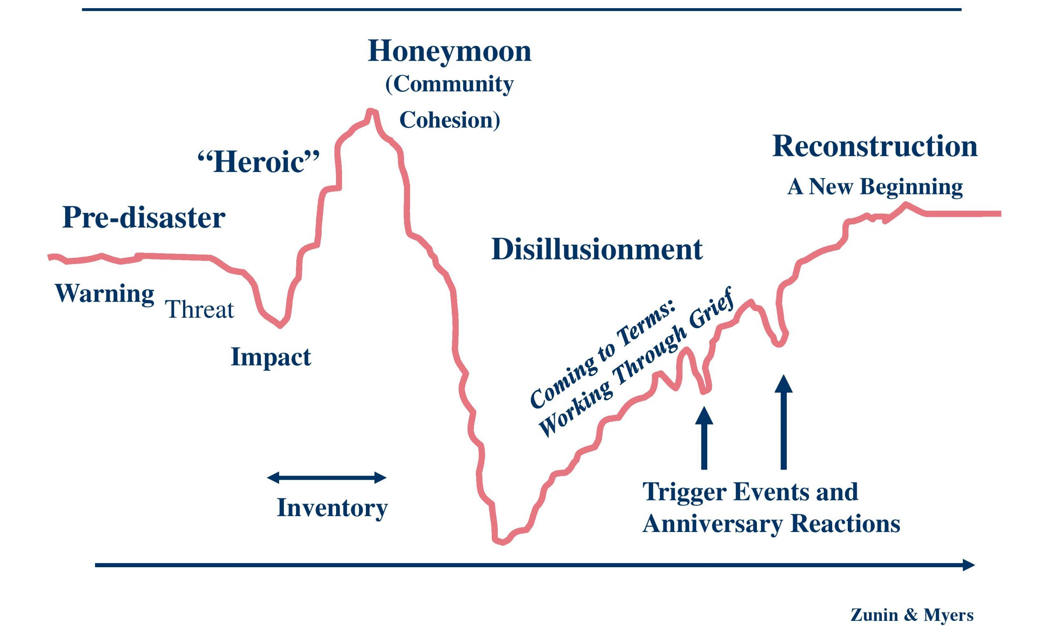
During the reconstruction phase the survivors finally realize they will be solving many of their problems themselves. Restoration begins to reaffirm their beliefs. Healthy growth occurs. This phase extends for six months and beyond and corresponds with the long-term rebuild stage.

During the disillusionment phase, survivors feel disappointment, anger, resentment, and impatience about delays when help does not materialize. They expected normalcy much sooner. The disillusionment phase can last two months to two years.

During the honeymoon phase, survivors may share common experiences and losses, engage in clean-up and relief efforts even as they anticipate help. The honeymoon phase may last one week to six months and corresponds to the recovery stage.

Reconstruction
Disillusionment
Honeymoon
Physical Effects of Disaster

God’s design for our bodies causes a chain reaction which help people respond to threats. To some extent, these responses enable people to perform better and faster. At some point, though, the body’s response can overwhelm the survivor and lead to diminished ability to cope. The brain’s ability to function can diminish with excessive stress response. The two halves of the brain lose the ability to communicate with each other. The front of the brain begins to shut down.
Because of this, people lose the ability to think clearly, communicate complex thoughts, and solve problems. They become impulsive (response chemicals prompt people to do something – anything) and tend to lose the ability to understand the consequences of their behavior. They may also lose the ability to function appropriately.

Disaster-Related Stress

A crisis is a temporary state during which a person’s usual methods of coping do not seem to be working. People tend to feel anxious and upset because of their apparent helplessness in dealing with the situation. A crisis may erupt when a person is faced with a problem which calls on resources or problem-solving abilities which have not been needed before. In other words, they lack experience in dealing with the situation.
Disaster-related stress is different. Survivors perceive disasters as highly dangerous and life-threatening to themselves and their families. They may fear the recurrence of a similar situation. Family members often jointly experience the terror-filled moments of the impact and extended recovery. Disasters cause a sense of helplessness and powerlessness over the forces which caused the crisis. Disasters cause a community-wide perception of destruction and disruption. Disasters result in a sense of loss of great magnitude and diversity.
Volunteers who provide direct ministry to the people affected by disaster can provide valuable assistance when they understand something of the stress caused by a crisis. Affected individuals suffer maximum stress when the crisis comes suddenly, causes widespread destruction, results in death or injury, occurs at night, and creates mountains of uncertainty.
Stress is minimized when the event is a natural disaster which can be blamed on unavoidable circumstances. If the disaster requires an immediate response, many times the stress is lessened. The stress caused by a disaster strengthens a community’s identity. Disasters reduce societal differences within a community and create a “here and now” mentality.
Psychologically, a disaster will absorb peoples’ attention (survivors, relief workers, and the public) but the types of reactions to disaster may vary. People tend to underestimate a disaster’s scope and to personalize the event. Disasters often provide an emotional release because other stresses subside and can provide a sense of renewal due to a break with the past. Personal and community milestones can also be developed.
What Disaster Relief Volunteers Can Do

- Be present. Your being with the survivor could mean more to them than you immediately see. In the aftermath of disaster, people often feel abandoned by family, by community, by systems and government, even by God. Remember Christ, the hope of glory, is in you. Grasp you may not only be representing Christ, but the people you help may actually see Christ in you.

- Listen. Let the individual tell his or her story. Use good listening skills such as:
◦ Look at the person and give them your complete attention. A good listener is always trying to understand, not trying to think of the next thing to say.
◦ Give occasional responses—nodding your head, changing expressions, making verbal responses, and asking questions. This lets the person know you are with them.
◦ Paraphrase and ask for clarification. However, do not put words in their mouth. Ask what happened?
◦ Avoid interrupting unless there is real confusion which jeopardizes your ability to help.
◦ Tolerate and accept new ideas. Do not condemn.
◦ Pay attention to your own body language. Convey you care. Be relaxed.
- Speak with sensitivity.
◦ Use simple sentences
◦ Be patient
◦ Avoid continually bringing the conversation back to your own experiences. Do not “one up them.”
◦ Help with problem solving; but use caution.
◦ Leave written information when possible
◦ Be an agent of hope.

Do not say:
“I know how you feel.”
“Remember Romans 8:28”
“It is only stuff, and you can buy more stuff.”
“It could be worse.”
“You’ll get over it.”

Rather, say things like:
“I am sorry.”
“How can we be helpful to you?”
“How can I pray for you?”
“Would you mind telling me about that/him/her?”
“It’s OK to be angry/confused/desperate, etc.”

- Pray. Ask permission, then voice your prayer. This is a powerful moment too often missed because of the fear of the volunteer. Keep it short, simple, and appropriate to the information and emotions shared by the survivor. Remember you are speaking to the Ever-Present Lord who has just witnessed your entire conversation - who knows us better than we know ourselves.

- Refer. Be honest with yourself and the one to whom you are ministering about your inability to help. Try to find someone who can help. Call upon a Disaster Relief Chaplain.

Survivor reactions at three stages of response:

Survivor Reaction During Emergency Relief:

The survivors’ reaction during the emergency relief period will depend upon the severity of the disaster and their personal losses. People tend to repress emotions. They may work until they reach the point of exhaustion and go without sleep, adequate food, or proper medical treatment. For themselves and their loved ones, they often act on the need for self-preservation, trying to salvage and protect what is left and recover what has been lost. They tend to be friendly, talkative, and want to share their experiences.

Survivor Reactions During Recovery:

During the recovery period, relief workers are on the scene. Survivors begin to slow down. Emotions surface. Decisions become difficult. They expect more from relief workers than may be possible. They need someone to listen to their stories.

Survivor Reactions During Long-Term Rebuild:

Long-term rebuild may begin one to six months after the disaster strikes. Many disaster relief agencies have left the community and most local help-givers have moved on to other things. They feel they should be back in their homes. Their emotions range from frustration to anger to pessimism to a state of fault-finding to depression. They feel no one cares and forgotten.

Appendix One: Personal and Medical Information Form
Appendix One: Personal and Medical Information Form 25
Appendix Two: Release and Indemnity Agreement 26
Appendix Three: Volunteer Skills Survey 27
Appendix Four: Volunteer Agreement with Convention Disaster Relief Director 28
Appendix Five: Deployment Checklist (What to Take) 29
Appendix Six: Responding SBDR Team Standard Operating Procedures-Activation, Deployment and Travel 30
Appendix Seven: Abbreviations, Acronyms, and Definitions ……..…………………………………………………..31

The Appendix
Appendices 1-7 are samples of documents state conventions may have customized for their own use.
State Deployed by:

MEDICAL RELEASE FORMS FOR VOUNTEERS
This Document Affects Your Legal Rights – Read Carefully Before Signing

Volunteer Information – Please Print
Volunteer Name: |  |  | Date:
Address:
City: |  | State: | Zip:
Home #: | Cell #: |  | Date of Birth:
Illnesses or conditions for which you are currently being treated:

Medications you are currently taking:

Allergies:
Date of last
tetanus or booster shot:
Health Insurance Company: |  |  | Policy Number:

Emergency Contact – Please Print
Relationship to Volunteer:
Name:
Address:
City: | State: | Zip:
Home #: | Cell #:

Primary Physician – Please Print
Name:
Address:
City: | State: | Zip:
Phone #:

Appendix Two: Release and Indemnity Agreement

WAIVER OF LIABILITY AND RELEASE OF CLAIMS
This Document Affects Your Legal Rights – Read Carefully Before Signing

I do hereby acknowledge that I, as a volunteer paying my own expenses, am entering upon a missionary venture with others for the purpose of helping, in times of disaster, for the glory of God; that the work may be hazardous and will be performed by other lay volunteers trained in disaster work; that vehicles transporting said volunteers will be operated by licensed though non-professional volunteers; and that there could be elements of risk in any portion of this venture.

I acknowledge the potential for motor vehicle accidents and accidents at job sites, or accidents in or around the living and eating areas and during other activities for the Southern Baptist Convention’s Disaster Relief Team; I am fully aware of the potential for accidents and injuries to myself and to other members of the Disaster Relief Team; therefore, I desire to protect, release, acquit, indemnify and hold harmless those listed in the following paragraphs from any and all claims and/or causes of action by me, my heirs, administrators, executors, and/or assigns.

Recognizing there is a risk of injury or death associated with virtually any type of activity, including those disaster relief, response relief and ministry activities which will be conducted by the Disaster Relief Team. I, ____________________________________ (also referred to herein as the “Participant”), do hereby represent as follows: (check all which apply)

( ) I have no physical, mental, emotional or other conditions or illness which would interfere with my ability to participate in any activity, or that would endanger my health or safety or the health or safety of others.
( ) I have a physical, mental, emotional, or other condition or illness which might endanger my health or safety or the health or safety of others if I were to participate in the following activities: ___________________________________________________.
( ) I do not wish to participate in the following activities: _____________________________.

CONSENT TO TREATMENT AND WAIVER AND RELEASE OF LIABILITY

As evidenced by my signature below, I hereby consent to participate in the disaster relief response activities and ministry, to be conducted under the supervision of employees, agents and/or volunteers representing Southern Baptist Convention (herein referred to collectively with all of its affiliates, employees, trustees, and representatives as “the Providers”).

In consideration of the Providers furnishing this opportunity to participate in the aforementioned activities, I agree as follows:

I fully understand and acknowledge that: (a) there are risks associated with the aforementioned activities; (b) by consenting to participate in those activities, I am accepting those risks and I recognize participation in those activities may result in injury, death or disability; (c) these risks may be caused by the negligence or gross negligence of the Providers; and (d) by consenting to and participating in these activities, I hereby assume all risks and all responsibility for any consequences of participation, whether or not caused in whole or in part by the negligence, gross negligence, or other conduct by the Providers.

On my own behalf and my family members, our personal representatives, and our heirs and assigns, I hereby voluntarily agree to release, waive, discharge, hold harmless, defend, and indemnify the Providers from any and all claims, actions, or losses for bodily injury, property damage, wrongful death, loss of services or otherwise which may arise out of the aforementioned activities. I specifically understand that I am releasing, discharging, and waiving any claims or actions that I may have presently or in the future for the negligent or grossly negligent acts or other conduct of the Providers.

I HAVE READ THE FOREGOING AND I UNDERSTAND THAT IT IS A VOLUNTARY RELEASE OF ALL CLAIMS.

CONSENT TO TREATMENT
In the event that I am for any reason rendered incapable of making decisions regarding my own medical care, I hereby consent to treatment, including diagnostic and surgical procedure; by a licensed physician should said physician determine that such treatment is necessary.

____________________________________________________ _____________________________________
PARTICIPANT DATE

Appendix Three: Volunteer Skills Survey

VOLUNTEER SKILLS SURVEY
Volunteer Name |  |  |  |  |  | date
Medical
- Doctor | - Nurse |  | - EMT | - Other _________________
Language
- Spanish | - French |  | - Other __________________________________
construction
- Carpenter | - Electrician |  | - Plumber | - General Contractor
- Architect | - Cement |  | - Drywall | - Structural Engineer
- Demolition | - Hazardous Materials |  | - Welder | - Building Maintenance
- Other:
heavy equipment
- Skid Steer | - Excavator |  | - Backhoe | - Bulldozer
- Crane | - Forklift |  | - CDL | - Wheel Loader
- Van/Bus | - Track Hoe |  | - Man Lift | - Dump Truck
- Other:
other skills
- IT Training |  | - Mobile Communications |  |  | - Social Media
- Security |  | - Administration |  |  | - Inventory
- Teacher |  | - Law Enforcement |  |  | - Fire Department
- Childcare/Daycare |  | - Legal |  |  | - Cook
- Other:

Appendix Four: Volunteer Agreement with Convention Disaster Relief Director
Volunteer Agreement with Convention Disaster Relief Director

As a volunteer member of the Baptist Convention of ____________________________ disaster relief team, I agree, as my availability and ability allow, I am expected to:

- Be a team player, serving with a Christ-like servant mindset and willingness to follow directions of Team, Unit, and IMT leadership.
- Complete a disaster relief skill checklist and keep current my (1) address and phone number, (2) availability status, (3) skills and abilities.
- Complete the required training and renew required training a minimum of every three years; take optional training which will increase my usefulness as a team member.
- Take responsibility for my spiritual and mental preparation as a disaster relief volunteer, as well as my work skills needed at the disaster site.
- Represent my Lord and Savior, church, fellow Christians, and team as Christ would want, in my attitude, behavior, speech, dress and work.
- Wear official disaster relief apparel and display the SBC Disaster Relief logo only as prescribed and only while engaging in a relief event.
- Protect my health and safety and the health and safety of victims, co-workers and all other persons while en route to or from and while at the disaster site; abide by the travel guidelines set forth by the convention DR director (Appendix Six); inform on-site team leaders of any physical limitations to be considered in my work assignments.
- Inform the convention DR director or association disaster relief coordinator of my availability for a disaster response.
- Take initiative in order to improve my usefulness; increase my availability by making adjustments in my other responsibilities in order to serve as a disaster relief volunteer.
- Pay my own expenses, arrange my own transportation, and bring clothing, bedding, and personal items I will need at the disaster site.
- Provide proof of insurance and health information to appropriate persons at the disaster site.
- Assist with unit preparation, training events and non-emergency use of the unit, as my availability and ability allow.
- Sign a release and indemnity document, if requested.

Therefore I , volunteer to do my best to help carry out the purposes of SBDR in the manner stated above.

Print Name: ____________________________________________________________ Date: ________________________

Signature: _____________________________________________________________

Appendix Five: Deployment Checklist (What to Take)

Deployment Checklist (What to Take)
(Always check with your Unit Leader for any special requirements)

Spiritual:
- Bible | - Journal | - Devotional | - Prayer Team

Identification:
- SBDR ID | - Driver’s License | - Medial Information

Miscellaneous Items:
- Cash | - Credit Card | - Notebook/pen/pencil
- Flashlight | - Water Bottle | - Snacks
- Phone / Charger

Clothing:
- DR Shirts/Hats | - Coat / Jacket | - Bedding/Cot/Mattress
- Sleepwear | - Jeans/Long Pants | - Proper Shoes
- Gloves | - Rain Gear | - Laundry Bag

Health / Safety / Hygiene:
- Medications | - Allergy Kits/Meds | - Sunblock
- Chapstick | - Personal Toiletries | - Towels/Washcloths
- OTC Meds | - Special Diet Food | - Deodorant

Appendix Six: Responding SBDR Team Standard Operating Procedures-Activation, Deployment and Travel
Responding SBDR Team Standard Operating Procedures:
Activation, Deployment and Travel

The following is policy adopted by SBDR Convention DR Directors in January 2015

It is understood emergencies arise which may impact the ability or appropriateness of following these procedures. Team leaders will be expected to communicate with the IMT when circumstances prevent adherence to the SOPs. It is expected the IMT and Team Leader will work out an agreed upon course of action in these instances.

- Upon Activation the Unit Leader will prepare a team roster and send it to the IMT using their convention’s reporting protocols.
- Upon departure for the response deployment location the Unit leader will report their departure to the IMT using their convention’s reporting protocols. (This one report is for all team members. Unit leader is responsible for keeping track of team members traveling separately)
- Team Leaders will contact the IMT when they are 20 minutes from their assigned deployment location.
- Additional contact with the IMT is not required unless team arrival will be delayed by more than 1 hour from the reported ETA.
- If the IMT needs to change an assigned traveling team’s deployment location they will notify both the team’s SBDR director and the traveling team.
- Teams will plan their arrival for not later than 9 pm at the response deployment location. To allow time to bed down before lights out.
- Teams will make every effort to arrive in time for the evening meal. To allow time for orientation and settling in before lights out.
- Teams will plan their departure time to allow the team at least 10 hours of rest. Departures before breakfast must be planned in agreement with the IMT and the team’s convention SBDR director.
- Teams will not travel more than 14 hours (11 driving) without at least 10 hours of rest. (The Host Churches for Traveling Teams project will work diligently to provide safe, overnight housing for teams.)

Appendix Seven: Abbreviations, acronyms, and definitions
Abbreviations, Acronyms, and Definitions

Term | Definition
Affected State | The state Baptist convention that has experienced a disaster and is responding to the needs of the affected area.
RC | American Red Cross
Assisting State | The designation for a state Baptist convention that has been called upon to provide disaster response assistance to another state that has been affected by a disaster.
Cambro | Hard, plastic container that keeps hot food hot and cold food cold for 24 hours or until the lid is opened.
Canteen | A mobile unit that delivers food and water to residents of a damaged area. (Salvation Army term)
CCV | Church/Community Volunteer
COAD | Community Organizations Active in Disaster
DEMOB | Demobilizing
DOC | Disaster Operations Center
DRC | Disaster Relief Center
DROP | Disaster Relief Operations Procedures - a manual that contains the operational procedures used by SBDR.
DR CRT | Disaster Relief Children’s Response Teams
EMA | Emergency Management Agency – the agency assigned by the government (city, county, state, and/or federal) to manage a response to a disaster and/or crisis.
EMD | Emergency Management Director (local government)
EOC | Emergency Operations Center
ERV | Emergency Response Vehicle – a vehicle used to deliver food and other supplies into communities affected by disasters.
ESF | Emergency Service Function
Family Processing Center | Location within the disaster area where agencies give assistance to disaster victims.
Feeding Unit | Mobile kitchen that prepares food in mass.
FEMA | Federal Emergency Management Agency
IC | Incident Commander
ICS | Incident Command System
IMB | International Mission Board – The Southern Baptist Convention’s agency assigned responsibility for international mission activity.
IMT | Incident Management Team
In-Kind Donations | Non-monetary donations (food, water, clothing, etc.)
Licensing Agency | State agency responsible for giving permission for DR CRT to function onsite in the aftermath of disasters.
MARC | Multi-Agency Resource Center
Mass Care | Refers to coordination of all emergency functions to meet the needs of disaster victims.
MOU | Memorandum of Understanding
NAMB | North American Mission Board – The Southern Baptist Convention’s agency assigned responsibility for North American mission activity.
NGO | Non-Governmental Organization
NIMS | National Incident Management System
PIO | Public Information Officer
PPE | Personal Protective Equipment
SBC | Southern Baptist Convention
SBDR | Southern Baptist Disaster Relief
SEMA | State Emergency Management Agency
SOP | Standard Operations Procedure
SR | Send Relief – the joint compassion ministry of NAMB & IMB
TSA | The Salvation Army
VOAD | Voluntary Organizations Active in Disaster
VRC | Volunteer Resource Center (non-SBDR)

Abbreviation | State Convention
ALSBOM | Alabama State Board of Missions
ABRN | Alaska Baptist Resource Network
ASBC | Arizona Southern Baptist Convention
ABSC | Arkansas Baptist State Convention
CSBC | California Southern Baptist Convention
CGR | Canadian Global Response
CBGC | Colorado Baptist General Convention
DBC | Dakota Baptist Convention
FBC | Florida Baptist Convention
GBMB | Georgia Baptist Mission Board
HPBC | Hawaii/Pacific Baptist Convention
IBSA | Illinois Baptist State Association
SCBI | State Convention of Baptists in Indiana
KNCSB | Kansas-Nebraska Convention of Southern Baptists
KBC | Kentucky Baptist Convention
LBC | Louisiana Baptist Convention
BCMD | Baptist Convention of Maryland-Delaware
BSCM | Baptist State Convention of Michigan
MWBC | Minnesota-Wisconsin Baptist Convention
MBCB | Mississippi Baptist Convention Board
MBC | Missouri Baptist Convention
MTSBC | Montana Southern Baptist Convention
BCNE | Baptist Churches of New England
BCMN | Baptist Convention of New Mexico
NBC | Nevada Baptist Convention
BCNY | Baptist Convention of New York
NCBM | North Carolina Baptists on Mission (Disaster Relief)
NWBC | Northwest Baptist Convention
SCBO | State Convention of Baptists in Ohio
BGCO | Oklahoma Baptists
PASJ | Baptist Resource Network of Pennsylvania-South Jersey
SCBC | South Carolina Baptist Convention
CIBSPR | Convention of Puerto Rico & US Virgin Islands
TBMB | Tennessee Baptist Mission Board
SBTC | Southern Baptists of Texas Convention
TBM | Texas Baptist Men
UISBC | Utah/Idaho Southern Baptist Convention
SBCV | Southern Baptist Convention of Virginia
BGAV | Baptist General Association of Virginia
WVCSB | West Virginia Convention of Southern Baptists

