Southern Baptist Disaster Relief

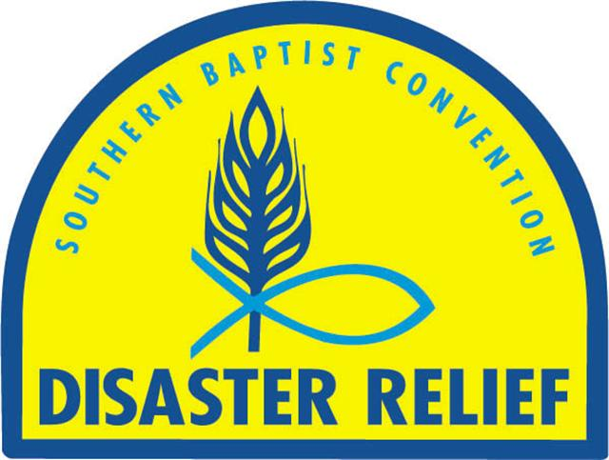
Feeding Manual

January 2017

Table of Contents

Cover Page 1
Table of Contents 2
Philosophy, Logo, and Purpose 3
Organizational Chart of SBDR Feeding 4
Training 5
Unit Specifications 6
Site Selection for Mass Feeding Response 7
Food Ordering and Menu Planning 8
Food Preparation and Distribution 9
Guidelines for Prevention of Accidents 10
Guidelines for Safe Food Handling in Personal and Work Areas 11-12
Safety Guidelines for Food Handling 13
Sanitizing Food Service Equipment 14-15
Propane, Gasoline, and Diesel 16-17
Inventory Management 18
Waste Disposal and Potable Water Safety 19
Mega Feeding Sites 20
Shut Down Procedures…………………………………………………………………………21

Appendix 22

Standard Serving Sizes 23
Cambro Labels 24
Ice Point Method of Calibrating a Thermometer 25
Information on and Sample Chart to Track Freezer/Refrigerator Trailer 26
Sample Menus 27-28
Push Packs 29
Typical American Red Cross Support Trailer Inventory 30
Standard Operating Procedures for Cambro Liners 31-34
Facility Agreement Between Church and SBDR 35
American Red Cross Facility Use Agreement Instructions 36-37
American Red Cross Facility Use Agreement 38-41
Web Search and Acronyms 42
Recognition Page 43

Philosophy

The purpose of Southern Baptist Disaster Relief (SBDR) efforts can be summed up by looking at biblical accounts of Jesus’ teaching and healing, such as feeding the multitudes, the parable of the Good Samaritan, and urging followers to minister to others in a variety of ways (Matthew 25:32-46).

Southern Baptist Disaster Relief is Christian love in action, responding to hurting persons and seeking to alleviate their needs whatever they may be. Disaster relief involves caring people responding to hurting people in a timely way. James 2:14-18 is one of many scriptural foundations for Southern Baptist Disaster Relief.

Logo

The Southern Baptist Disaster Relief logo incorporates both physical and spiritual ministry as exemplified by Jesus.

The fish represents the spiritual aspect of ministry. Early Christians used the sign of the fish as a mark of identification, especially during times of persecution. Later, the letters of the Greek word for fish, ichthus, were used to form an acrostic. Each letter in “ichthus” is the first letter of another Greek word. Traditionally, the acrostic meant Jesus Christ, God’s Son, the Savior.

The head of wheat represents bread: food, physical ministry.

The shield, which forms an arch over the wheat and the fish, represents the scope of cooperation by Baptists in disaster relief ministry.

The Southern Baptist Disaster Relief logo is a registered trademark of the North American Mission Board (NAMB). Permission has been granted by NAMB for use of the logo by state disaster relief directors. Any other use of the logo requires explicit written permission from the state disaster relief director and/or NAMB.

Purpose

The purpose of this feeding manual is to provide guidance and information for disaster relief volunteers engaged in feeding operations to promote and ensure consistent procedures for the safe storage, handling, preparation, and distribution of food to disaster clients and workers. The manual is designed as a resource to support state conventions disaster relief and to supplement state conventions training endeavors. Nothing in the manual is to be construed as overriding state and local laws and regulations, nor are the guidelines designed to replace appropriate procedures currently being used in state convention disaster relief training.

Organizational Chart of SBDR Feeding

State Director

Incident Commander

Operations

Chief Cook/
Food Prep

Equipment/
Maintenance

Inventory/
Warehouse

Sanitation/
Wash Unit

Food Delivery
Coordinator

Blue Hat/Field Kitchen Manager

Feeding
Coordinator

Training

Each Baptist convention will train and maintain volunteers as described in this Feeding Manual adopted January 2017. Southern Baptist Disaster Relief leadership has chosen to use hats for recognition of leaders. These have been found to be easily identifiable at operational sites.

Specialized Training

Incident Commander (White Hat)
The incident commander is the leader of the ICS (Incident Command System) team. The incident commander should have FEMA training.

Feeding Coordinator
This position coordinates the field kitchens and is direct liaison to activating agencies (state/county EOC, American Red Cross, The Salvation Army).

Blue Hat/Field Kitchen Manager
Blue Hats/Field Kitchen Managers are part of the ICS team. Blue Hats should have a ServSafe Manager certification.

Feeding Unit Disaster Relief Volunteer (Gold Hat)
A feeding unit disaster relief volunteer should be trained by the state convention in a comprehensive training program based on ServSafe principles and disaster relief field operations.

Unit Specifications

Individual states have various sized feeding units. These are classified in the following ways:

Type I (D) feeding unit
- Capacity to prepare above 20,000 meals per day
- Equipment will include at least four to six 30-gallon (or larger) pieces of cooking equipment
- At least six convection ovens or equivalent equipment (tilt skillet, steamer, kettle, or combination convection oven/steam oven)
- Recommended minimum 50 volunteers

Type II (C) feeding unit
- Capacity to prepare up to 20,000 meals per day
- Equipment will include three or four 30-gallon (or larger) pieces of cooking equipment
- Four convection ovens or equivalent equipment (tilt skillet, steamer, kettle, or combination convection oven/steam oven)
- Recommended minimum 40 volunteers

Type III (B) feeding unit
- Capacity to prepare up to 10,000 meals per day
- Equipment will include two 30-gallon (or larger) pieces of cooking equipment
- Two convection ovens or equivalent equipment (tilt skillet, steamer, kettle, or combination convection oven/steam oven)
- Recommended minimum 30 volunteers

Type IV (A) feeding unit
- Capacity to prepare up to 5,000 meals per day
- Equipment will include stove burners, cookers, and double boilers
- One convection oven or tilt skillet
- Recommended minimum of 15 volunteers

All unit capacities use either canned or pre-cooked frozen food. The unit should be able to sustain this type of production for two weeks based on a 12-15 hour day and preparation of two meals a day.

Site Selection for a Mass Feeding Response

Operations are usually set up at a Southern Baptist church facility, but on occasion kitchens have been set up at facilities of other denominations, armories, recreation buildings, schools, and parking lots. Church facilities are usually pre-selected by the state director or NAMB. The Blue Hat/Field Kitchen Manager, in coordination with a facility representative, determines how to set up the site. Here are some factors that should be considered to accommodate a mass feeding operation.
- Space – No matter which class feeding unit you have, there must be sufficient room to set up the unit and auxiliary equipment, including storage units.
- Location – The location must be close enough to the affected disaster area that food can be transported or clients/disaster survivors can be served on site. The location must be safe and secure both day and night.
- Buildings – Buildings must be large enough to house the disaster relief volunteers. It is desirable to have multiple rooms for sleeping, but sometimes an open gym is all that is available. We use what is available for sleeping quarters.
- Restrooms – A sufficient number of restrooms should be provided for the volunteers. If restrooms are not available, portable restroom/approved hand wash stations should be provided in sufficient numbers to handle the volunteers.
- Shower units/laundry units – If the church facility does not have adequate showers, a shower unit will be brought in for the volunteers. (Note: If the public will be using these facilities, they must be set up so they can be accessed without going through the disaster relief sleeping and food processing/storage areas.)
- Traffic flow – The operational area should be set up so American Red Cross emergency response vehicles (ERVs) or The Salvation Army canteens can drive up to drop off dirty food containers (cambros) and continue to the loading area and exit without backing up.
- Parking lot – The parking lot must be able to handle commercial vehicles. Boards, (2x12) must be placed under the landing gear of trailers to prevent damage.
- Parking – Consider the number of volunteers and visitors in addition to the feeding equipment and inventory areas.
- Serving line – There may be a request to set up a serving line to feed the local community.
- Water supply – Confirm that the water supply is potable and adequate.
- Gray water – Access to the sanitary sewer for the unit’s gray water is a necessity. Most drain fields are not capable of taking the gray water volume that will be dumped during a large operation. When there is no sanitary sewer access, consult with local authority regarding disposition of gray water. Gray water relates to water used for showers, hand washing, and kitchen cleanup.
- Electricity – All units should carry generators that are large enough to power their complete operation.
- Commercial dumpster – The site must have adequate space for commercial dumpsters located away from the food preparation area.
- Written approval – A Facility Agreement (see appendix) should be completed by a representative of the facility and the unit. RC/TSA equipment may also be on the grounds using the facility. When RC personnel/equipment is on site, the appropriate RC/TSA Use Agreement should also be signed (see appendix). Pre-inspection and post-inspection forms should be used. Copies of the agreements/forms should be kept on the units. Generally, material support services of RC are responsible for the facility agreements. However, if RC is not present at the beginning of the operation but will be on site, the Baptist unit director is authorized to complete the agreement on behalf of RC.

Food Ordering

- Blue Hat/Field Kitchen Manager places order with the SBDR representative at the activating organization’s operations center.
- A menu plan has been prepared to assure 8 oz. entrée, 6 oz. vegetable, and fruit portion agreement with RC/TSA/SBDR
- Utilize US Foods and/or Sysco preplanned order forms and/or electronic ordering when possible.
- Be practical when ordering, considering equipment, personnel, and number of meals required. Always coordinate food orders with inventory already on hand.
- Order only precooked meat products. We do not have the equipment, training or capacity to safely prepare raw meats.

Menu Planning

- The Blue Hat/Field Kitchen Manager will plan the daily menus in coordination with the RC/TSA onsite leader, head cook and/or inventory personnel.
- Remember some food products take much longer to prepare than others. Plan one easier and one harder meal per day.
- Plan menus that will utilize all cooking equipment (convection ovens as well as tilt skillets) to maximize output.
- Take into consideration regional food preferences.

Food Preparation and Distribution

Preparation

To produce the number of meals needed during a major disaster, canned and/or frozen precooked food is used. The following guidelines should be remembered.
- Meats, vegetables and fruits in #5 or # 10 cans are usually necessary during the first two to three days of food preparation. Individual servings of fruit/pudding in 4 oz. cups are preferred when available.
- Frozen, precooked (freezer to skillet only) can be used if necessary.
- Frozen, precooked foods which require thawing prior to heating must be thawed under refrigeration at 41° F or less. This process usually takes about three days.
- When using frozen foods three to four refrigerated units are needed for the stepdown process of thawing. Partitioned refrigerated units aid in the processing of frozen items.
- All cans need to be sanitized prior to opening.
- Commercial quality can openers are necessary for large food operations.
- Southern Baptist feeding units cannot handle raw meats or vegetables because of food safety issues. Cooking times for raw products would severely reduce the production capability of the units.
- SBDR cannot accept home grown/canned items. All food used must come from an approved food source.

Distribution

Prepared food distribution can be accomplished in several ways. Southern Baptist kitchens prepare the food, which is transported in Cambro’s® to maintain the proper serving temperature.
- American Red Cross distributes the food through their Emergency Response Vehicles (ERV’s) on set routes, to fixed feeding sites, or to shelters.
- The Salvation Army distributes the food from their Canteens, fixed feeding sites, or to shelters.
- Local churches or community resources may distribute the food from fixed feeding sites as can the Feeding Unit.
- Fixed feeding sites bring the food closer to the disaster survivors.

Guidelines for Prevention of Accidents

To Prevent Injury

- Do not touch electrical outlets or appliances with wet hands or while standing on a wet surface.
- Contact the Blue Hat/Field Kitchen Manager or Maintenance team to replace worn or damaged electrical cords, plugs, etc.
- Learn to operate mechanical and electrical equipment (coffee pots, slicers, etc.) before using them.
- Always close drawers and cupboards.
- Have sufficient light in work areas.
- Never touch downed lines of any kind.

To Prevent Fires

- Make sure there are no gas leaks before lighting a gas stove or other appliance.
- Keep type BC or ABC fire extinguishers in convenient places throughout the cooking area. Each extinguisher should be a minimum of 5 pounds.
- Remember PASS to use the fire extinguisher correctly.
- P = Pull the pin
- A = Aim at the base of the fire
- S = Squeeze the handle
- S = Sweep the extinguisher back and forth, remembering to aim at the base of the fire
- Follow safety requirements when refueling is taking place. Extinguish all fires, including pilot lights, before refueling starts. Check connections with liquid soap before re-lighting gas appliances. Avoid use of flammable cleaning fluids. Store all flammable fluids away from fires.
- Extinguish grease fires by clamping a tight lid over the flame to starve it of oxygen. Be sure hands, arms, face, and body are protected. Never use water to put out a grease fire.

To Prevent Burns

- Turn equipment handles away from the edges of stoves and tables to prevent tipping.
- Wear gloves or use well-padded, dry potholders to handle pans and lids. Never use towels or aprons as potholders.
- Wear oven mitts to remove pans from ovens. Protect arms.
- Lift lids from hot pots slowly, the furthermost edge first. Let steam escape away from face and arms.
- Keep matches in covered cans and provide metal containers for burned matches. Preferably use long-handle butane lighters.
- Avoid use of flammable cleaning fluids. Store all flammable fluids away from fires.
- Extinguish grease fires by clamping a tight lid over the flame to starve it of oxygen. Be sure hands, arms, face, and body are protected. Never use water to put out a grease fire.

To Prevent Cuts

- Provide a holder and a safe storage place for knives. Do not store knives loosely in drawers with other utensils.
- Wash knives by themselves; do not put in dishpan with other utensils.
- Use broom and dustpan to pick up broken glass. Wrap well, mark clearly, and place broken glass in special container for disposal.
- Can lids should be stored in an empty can, never put loosely in a garbage container.

Guidelines for Safe Food Handling in Personal and Work Areas

Personal

Do’s
- Wear clean, washable outer garments.
- Wash hands frequently with soap and water and dry with a clean paper towel.
- Wash and dry hands carefully after using the toilet.
- Wash and dry hands carefully after smoking.
- Keep fingernails trimmed and free of dirt.
- Wear gloves made of proper material for the task.
- Use forks, tongs, spoons, and ladles in handling and serving food.
- Wear hair covering, uniform cap, or hair net at cooking and serving sites. No pins on hats or lanyards.

Do Not’s
- Handle food if you have signs of disease or illness, cuts, infection, sores, diarrhea, sore throat, cold, or congestion.
- Sneeze, cough, or blow nose or scratch scalp near food.
- Moisten fingers by putting them in your mouth.
- Use tobacco while working around food.
- Touch sanitized eating utensils.
- Take medicines in food prep or serving areas.
- Wear aprons to the restroom.

Work Areas

- Follow all guidelines for food handling and sanitation.
- Keep walking and standing areas free of standing water.
- Keep passageways, stairs, serving areas, and work areas clear of boxes, tools, or other obstructions.
- Remove or cover spilled grease, fat, oil, water, or food immediately. Clean area and cover if still slippery.
- Wear suitable shoes for the occasion: low heels, treaded sole, soft soles on hard surface, waterproof in damp area, heavy duty with heavy lifting, etc. Never wear open-toed shoes.
- Provide sufficient light in work areas. Shine a flashlight before reaching into dark places.
- Wear gloves and aprons while using sanitation supplies or other chemicals that may affect the skin. Change gloves and aprons immediately after handling chemicals. Avoid prolonged contact with or breathing fumes from cleaning chemicals.
- Bandage cuts, scrapes, or burns immediately.
- To reach high places, use a stepladder. Do not stand on chairs, stools, tables, pallets, or boxes. Follow guidelines for preventing falls.
- Disconnect electrical equipment before cleaning. Do not touch outlets or equipment with wet hands or while standing on wet ground or a wet floor.
- Avoid barehanded contact with ice or frozen food.
- Know proper use of mechanical and electrical appliances before using.
- Replace worn or damaged electrical cords, plugs, connections, and bases as soon as wear or damage is discovered.
- Keep hands and clothing away from moving parts on mechanical and electrical equipment.
- Watches, ties, jewelry, etc., can’t be worn in the food prep area. The only permissible ring is a plain band.
- Get adequate rest, stay alert, and watch out for the welfare of others.
- Make safety and hygiene a priority. Get plenty of fluids and nourishment so you can achieve your fullest effectiveness and that of your team’s.
- Follow all safety requirements.
- Tow motor/forklift operators must meet the certification standards of the state convention.

Safety Guidelines for Food Handling

All persons involved in food preparation, service, or delivery at mobile feeding units must be extremely concerned about prevention of food borne illnesses and control of sanitation and hygiene.

Food Handling

- Use only clean, unspoiled foods obtained from an approved source.
- Protect foods and water supplies from contamination by airborne particles (dust, pollen, hair, and spores), splashing, flies, vermin, rodents, and drainage.
- Limit use of foods that is known to be ideal media for bacteria growth: cream fillings or sauces, meat salads and dressings, stuffing or hashes, baked or broiled ham, raw ground meat, meat pies, and salads with mayonnaise (potato salad, etc.).
- Avoid foods or preparation procedures that require much handling.
- Refrigerate perishable foods at temperatures at or below 41° F.
- Cook to recommended temperatures (160°-180°) using a thermometer and process all foods in sanitary work areas.
- Prepare foods as near to serving time as possible and keep hot until served. We can serve food from cambros with no additional heat for 4 hours after it drops below 135 degrees or rises above 41 degrees, according to “Rules of 4.”
- Use calibrated thermometers. (See appendix.)
- Protect foods during delivery and when serving from unsafe cooling and contamination.
- Cover food and drink containers whether empty, clean, or soiled.

Safety Guidelines

- Use a safe water supply and sanitary water delivery (lines, pipes, hoses, and containers) obtained from an approved source.
- Maintain clean preparation facilities, tables, equipment, and utensils.
- Maintain clean, safe, and protected serving supplies, equipment, utensils, and eating areas.
- Dispose of refuse and waste in a safe, sanitary manner and keep it away from preparation and serving areas.
- Maintain clean and dry storage areas free from rodents, insects, and other animals or vermin.
- Maintain clean, safe, controlled refrigeration storage to keep foods at or below 41° F.
- Use containers made of safe materials. Never use galvanized cans for cooking or storage, except for packages of dry staple foods.
- Practice meticulous personal hygiene and sanitary food handling.
- All food handlers must wear single use gloves. To prevent contamination change gloves after any possible contamination, using restroom, handling food, touching any surface, eating, drinking, handling chemicals/garbage and when returning to kitchen area. If in doubt Change Your Gloves. Replace gloves if they become punctured or every four hours.
- Wash hands often, with warm water of 100°F, before and after handling food, perishables, chemicals, and cleaning utensils. Use soap and dry hands thoroughly with a single use paper towel.
- Completely clean and then sanitize workstations frequently, using a properly mixed sanitizing solution (bleach, quats, etc.) then air dry.
- Deal with pests such as flies, bees, mosquitoes, etc., as safely as possible. Avoid spraying pesticides in food preparation and serving areas.

Sanitizing Food Service Equipment

Using Chlorine Bleach

- Dilute mixtures of chlorine bleach and water are a common and cost-effective method for sanitizing equipment in food processing operations.

- Equipment or articles sanitized with the solution must be allowed to drain adequately before contact with food.

- Solutions used for sanitizing equipment shall not exceed 200 parts per million (ppm) available chlorine.

- About one tablespoon (½ fluid ounce, 15 ml) of typical chlorine bleach per gallon of water is the maximum that should be used for sanitizing food contact surfaces, according to federal regulations. If higher concentrations are used, the surface must be rinsed with potable water after sanitizing.

- Contact times of one to five minutes are usually sufficient to achieve a thorough kill, depending on the chlorine concentration and organic load.

- Temperature of the water used to dilute and apply the chlorine as a sanitizer should be 105-120° F.

Desired chlorine concentration | Amount of chlorine bleach (5.25% sodium hypochlorite) needed | Amount of water needed
50 ppm | ¾ tsp | 1 gallon of water
50 ppm | 1 Tablespoon (½ oz.) | 4½ gallons of water
50 ppm | 2½ Tablespoon (½ oz.) | 10 gallons of water
100 ppm | 1½ tsp | 1 gallon of water
100 ppm | 2 Tablespoons (1 oz.) | 4½ gallons of water
100 ppm | 5 Tablespoons | 10 gallons of water
200 ppm | 3 tsp | 1 gallon of water
200 ppm | 4 Tablespoons (2 oz.) | 4½ gallons of water
200 ppm | 10 Tablespoons (5 oz.) | 10 gallons of water

Sanitizing continued

Three Sink Method of Cleaning

- Scrape waste from pots and utensils into waste receptacle; dispose of waste.
- Pre-rinse pots and utensils to prevent excess particles in wash water.
- Wash in first compartment of sink.
  - Use soapy water, 110°-120° F.
  - Change water often and when refuse or temperature dictates.
  - Remember that detergent or soap is a cleaning agent, not a sanitizing agent.
- Transfer to second compartment.
  - Rinse in water 110°-120° F.
  - Place small items in wire basket or pail.
  - Place container with small items in rinse water.
  - Rinse pots, pans, and utensils.
- Transfer to third compartment.
  - Use water at least 180° F or sanitizing solution (see previous table).
  - Immerse for two minutes.
  - Remove and place on drain board; do not dry with a towel.
  - NOTE: Extreme care should be taken if using the hot water sanitizing method.
- Store sanitized utensils, pots, and equipment appropriately making sure no food particles are left in containers, brushes, sponges, cloths, etc.
- Clean floor surface of sanitation area with hot soapy water or chlorine solution. Leave no standing water.

Stock Tank Cleaning with High Pressure Hot Water

- Rinse, scrape, or soak all items before placing in the first stock tank. Remove all tape and labels.
- Transfer to stock tank #1.
- Blow all food items and grease from inside and outside of container with the high pressure hot water.
- Do not use detergent in this operation.
- Transfer to stock tank #2.
- Rinse all items in water that is 100°F to 120°F and contains a chemical sanitation solution for 30 seconds.
- If sanitizer is used, maintain manufacturers recommendation concentration and check levels every couple of hours by test strip.
- Air dry items on drying racks or drying tables.

Propane, Gasoline, and Diesel

Propane
- Transport and store LP tanks in an upright position.
- Inspect tanks for corrosion, damage, and wear.
- Inspect lines and appliances for wear and damage.
- Keep fire extinguishers and first aid kit within reach.
- Propane tanks must be secured with a chain to a fixed object.
- Secure valves with covers when possible.
- Keep the following nearby for refueling or inspecting tanks and connections: wrench, screwdrivers, other related tools, copper wire, flashlight, liquid soap.
- Have tanks filled by a professional dealer or capable representative. Refuel in open area. Only essential persons should be in the area.
- Instruct volunteers prior to start of refueling:
  - Extinguish fires, flames, and pilots; remove potential spark sources (electric sources, motors, static electricity). Make sure generators are shut down.
  - Evacuate away from unit.
  - Do not offer to help, or help when asked.
  - No smoking anywhere in area by anyone.
  - Warn guests and insist upon strict compliance with all of the above.
- Use a CALL-OUT WARNING SYSTEM prior to refueling or connecting/disconnecting tanks, lines, or appliances. That is, call loudly that refueling is about to take place. See that the warning is repeated again so that no volunteer or anyone else fails to get the warning.
- When connecting or disconnecting lines, close all valves.
  - When connecting fuel lines, begin at appliance and proceed to tank, with all valves closed.
  - When disconnecting appliance, turn off main valve at tank and check valves back to appliance. Check and extinguish all flames within safe distance. Then disconnect from tank to appliance.
- Install check valves on lines as back-up, where possible.
- Check for open flames or other fire or spark sources.
- After each refill, check connections for leaks with liquid soap. If leak is present, keep volunteers and others away until safe.
- Light pilots with a small torch (flame that won’t blow out).
- Turn appliances on; adjust pilot lights and flames.
- Be acquainted with maintenance procedures on refueling.

Onsite Refueling – IF PERMITTED

Small LP tanks (4 lb. to 100 lb.) may be filled on site if they are equipped with an OPD (overfill prevention device) valve. The delivery truck must have an adapter for these tanks.
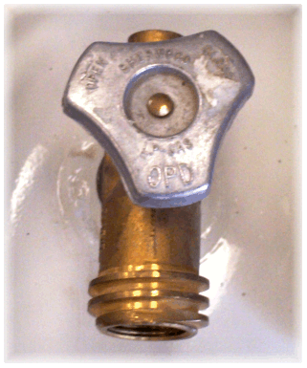
How to tell if you have an OPD valve:
- The valve must have the triangular handwheel.
- The handwheel (if triangular) should have the letters OPD stamped into it.
- Not all OPD valves have outside threads; however, most do.

Propane continued
Information
There are multi valves for 100 # cylinders which can be located at propane supply warehouses for around $100. These valves must be installed by a certified technician. The advantage to using this valve is most states will fill the tanks on site from propane tanker trucks without breaking connections.
Propane tanks are "date stamped. Date stamps are located on the collar of the tank. An example is 09-12 which is September, 2012. The tank is good for 12 years and if a tank is out of date it must be recertified before it can be filled. A recertification is good for 5 years and can receive the recertification 3 times total.
Gasoline/Diesel

- No smoking
- Have a secure refueling area
- Shut off engine
- Make sure you have a cool-down period, NEVER fill a hot engine
- Do not fuel if there is a source of ignition in the immediate area
- Make sure equipment is grounded
- Fuel with proper fuel/equipment
- DO NOT OVERFILL
- Do not leave unattended while fueling
- After filling check for any spillage
- Return all equipment in the area back to operational status
- It is important to have someone in maintenance to be responsible for tracking fuel and temperature in refrigerated units. See chart in Appendix.

** MSDS (material safety data sheet) by calling 800-689-3998. MSDS provides safety and first aid information in case of eye or skin contact, inhalation or ingestion of fuel.

SAFETY IS EVERYONE’S DUTY

Inventory Management
For proper food use and handling, a good inventory plan is essential during the initial, on-going and closing phases of a disaster response. A person who has the gift of organization should be given the task of inventory manager.
Initial Inventory Control
- Prepare within 24-48 hours of arrival at the kitchen site an initial inventory of food and equipment brought to the disaster with the feeding unit.
- Initial inventory with documentation will be presented to the Blue Hat/Field Kitchen Manager and the activating agency.
On-going Inventory Control
- Keep a copy and list of invoices and receipts related to food and supplies.
- On-going Inventory and Bill of Lading must be submitted within 24-48 hours of arrival at designated kitchen site to the Blue Hat/Field Kitchen Manager and activating agency
- Keep a daily inventory after initial processing of food and supplies that is available to the Blue Hat/Field Kitchen Manager and activating agency.
- The Blue Hat/Field Kitchen Manager will prepare a pull order daily for the Inventory team.
- Keep pertinent information of all trailers (owner, vehicle number and license number).
- Establish a warehouse or trailer grid identifying the location of products.
- Store all food on pallets.

Closing

- Prepare a complete closing inventory of food, paper goods, and all equipment.

Waste Disposal

Liquid Waste Water
- Consult with local authorities on the disposal of liquid gray water.
- If a large collection bladder is used, a professional hauler must be obtained to transport gray water.

Solid Waste (paper, cardboard, cans, food, etc.)
- Garbage and refuse should be kept in durable, easy-to-clean, insect proof, rodent proof containers that do not leak, do not absorb liquids, and have covers that fit. Plastic bags may be used to line these containers.
- There should be a sufficient number of garbage containers to hold the garbage and refuse that accumulates.
- Garbage and refuse should be disposed of frequently to prevent the development of odors and the attraction of insects and flies.

Outside garbage storage containers are traditionally large construction dumpsters. These containers should be located away from the food production area yet close enough for frequent trash dumps. The areas around the containers must be kept as clean as possible. All bulk food should be double plastic bagged before depositing in the dumpster. The schedule for pick-up or emptying of these dumpsters should be daily (or more often if necessary) to be free of pests and to keep the area clean. Leakage around a dumpster should be pressure washed daily.

Potable Water Safety

- Drinking water should be obtained from one of the following approved sources:
  - public water system
  - non-public water system that is constructed, maintained, and operated according to law of state drinking water quality standards
  - water buffalo or tanker supplied by a local government agency
- Verify that water systems being used are potable.
- Bottled drinking water used or sold in a retail establishment should be obtained from approved sources in accordance with local and state health department regulations.

Mega Feeding Sites

Mega feeding sites are set up at the request of the affected state convention in cooperation with our partners for the purpose of generating a higher daily meal count than a type I (D) unit (30,000 meals) can produce. The site location in the affected community could very possibly be something other than a Southern Baptist church facility, such as a fairground, school, community center, or shopping center, due to the large amount of volunteers, support equipment, and materials needed for the operation.

Because of the cooperative spirit of Southern Baptist Disaster Relief volunteers, mega sites have been successful in meeting the needs of affected communities and our partners. Clear, concise communication up and down the chain of command is the foundation of our success. First, the affected state convention disaster relief director assigns the site coordinator (white hat), whether the mega feeding site is a one-state or multi-state operation. Second, the site coordinator establishes a clear line of communication with the Blue Hats/Field Kitchen Managers as to their daily responsibilities and expectations.

The following points should be considered when operating a mega feeding site:

- One experienced site coordinator (white hat) should run the site. This person must be familiar with feeding, not simply a “good white hat” from another area of work.
- The site coordinator may appoint others to assist in the running of the site, similar to an onsite incident command team. For example, he/she may appoint:
  - an inventory coordinator who keeps up to date regarding food supplies and deliveries on site
  - a trash coordinator who facilitates the collection of trash and keeping the site clean
  - a menu planner who facilitates with the inventory coordinator and American Red Cross kitchen manager several days of menus
- If multiple units are on site, each unit should be run by a blue hat, not a white hat. A coordination meeting should take place daily. Cooperation is crucial.
- A relationship with American Red Cross or Salvation Army kitchen coordinator is essential. He/she is responsible for securing the food, distributing the food by ERVs, etc. This person should be a part of the daily update meetings with SBDR.
- Cooking large quantities of meals produces a lot of trash and strains the equipment. This type of operation is larger than most volunteers have seen or been a part of. It can be intimidating to SBDR volunteers if they are not prepared. The key is trained, experienced leadership (site coordinator/White Hat and Blue Hats/Field Kitchen Managers) in food preparation and delivery. Coordination and cooperation are crucial. A mega feeding site is not the place or the time for on-the-job training of key leadership. Additionally, key leadership should remain stable; that is, the site coordinator should remain on site for a given period of time (at least one week and preferably two weeks). The same is true for the Blue Hats/Field Kitchen Managers—they should remain onsite for a minimum of one week. Leadership changes after only a few days will complicate the ministry.
- The basic principles for inventory, storage, cooking, distribution, sanitation, and safety remain the same as in smaller operations. The difference is in terms of the volume of meals, equipment, personnel, and vehicles.
Shut Down Procedures

Kitchen Site Closing

Recommendations to close kitchens sites must be made jointly between the SBDR Incident Management plus Blue Hat/Field Kitchen Manager and the American Red Cross DRO plus the Kitchen Site Manager. Those recommendations must be communicated to all parties with final decisions communicated to Operations Management (OM) and properly posted and communicated to clients.
- Plan at the kitchen site with the SBDR Blue Hat/Field Kitchen Manager a recommendation for the closing of the field kitchen operation including:
- The date and time (lunch, dinner) of the last day of feeding
- Arrangements for the return of USDA commodities
- Disposition of all remaining food and supplies
- Deliver 48 hours advance closing notice to all parties including the organizations’ management, clients and workers
- Communicate recommendation to Red Cross Feeding Manager and SBDR Coordinator at the DRO headquarters
- Establish procedures for the removal of ancillary services (i.e. garbage, recycling, etc.) at the kitchen site.
- Develop a plan for restocking the field kitchens based on conversations with the Field Kitchen Manager and from the initial order or orders at the DRO location.
- Receive from each field kitchen a closing inventory of food, paper goods, and all equipment remaining on the unit. All food needs to be restored to supply trailer (US Foods, SYSCO, etc.) if they have been stored outside.
- Products need to be secured to pallets with plastic wrap ready to be transported.
- Clean the site completely.

Appendix

- Standard Serving Sizes and Meal Count by Portions Using #10 Cans

- Cambro Labels

- Ice Point Method of Calibrating a Thermometer

- Information on and Sample Chart to Track Freezer/Refrigerator Trailer

- Sample Menus

- Push Packs

- American Red Cross Support Trailer

- Standard Operating Procedures for Cambro Liners

- Facility Agreement Between Church and SBDR

- American Red Cross Facility Use Agreement Instructions

- American Red Cross Facility Use Agreement

- Links and Acronyms

- Recognition

Standard Serving Sizes

(as agreed upon by American Red Cross and The Salvation Army)

Standard serving sizes for meals on disaster relief operations are:

- Entrees: 8 oz. (includes meat, pasta/starch/bread)
- Vegetables: 6 oz.
- Fruit: 6 oz. (Fruit and pudding 4 oz. serving acceptable if individual serving)
- Bread (if not served as part of the entrée, as in a hamburger)

The above sizes are averages. For entrees, this size refers to items such as stews, soups, chili, casseroles, or hot dishes. A number of exceptions are listed below. Final determinations should be made at the kitchen site using the above portion sizes as a guide.

- Spaghetti/stroganoff: 4 oz. noodles and 4 oz. meat sauce/gravy
- Chicken breasts: 1 breast
- Sliced meats: 1-2 slices (based on an 8 oz. serving size)

Sample Cambro Labels

The following information should be placed on every cambro with label or tape.

Blank Label

NO. OF SERVINGS: ______________ SERVING SIZE: ________________
CONTENTS: ____________________________________________________________
TEMPERATURE: ________ DATE: _____________ TIME FILLED: _________________
DELIVERY VEHICLE #: ______________

Sample Label

NO. OF SERVINGS: __150_________ SERVING SIZE: ___6 oz._________
CONTENTS: ____Mashed potatoes__________________________________________
TEMPERATURE: _180____ DATE: _1/17/17____ TIME FILLED: ___9:45 a.m._______
DELIVERY VEHICLE #: __1773________

Ice Point Method of Calibrating a Thermometer

Follow these steps to calibrate a thermometer using the ice point method.

- Fill a large container with crushed ice. Add tap water until the container is full. (Note: Stir the mixture well.)

- Put the thermometer stem or probe into the ice water. Make sure the sensing area is under water.

- Wait 30 seconds or until the indicator stops moving. On thermocouples and thermistors, wait until the readout stops moving. (Note: Do not let the probe touch the container.)

- Adjust the thermometer so it reads 32°F (0°C). How you do this depends on the type of thermometer being used.

  - Bimetallic stemmed thermometers - Hold the calibration nut with a wrench or other tool. Rotate the thermometer head until it reads 32°F (0° C).

  - Thermocouples and Thermistors - Follow the manufacturer’s directions. On some devices, you can press a reset button.

Information and Sample Chart on Freezer/Refrigerator Trailer

- Document the temperature of both the freezer and refrigerator section twice each shift.

- Check engine oil ONCE A DAY.

- Check fuel levels every 4 hours for small tanks and once per shift for larger tanks,

- If the unit does not have an auto defrost the unit should be defrosted every 4 hours by depressing the defrost switch.

- Shut the unit off if the doors are to be open more than 10 minutes. Preheat and restart the engine after work is complete.

- Ensure that the doors are shut properly when exiting.

Restarting the unit after running out of fuel.

- Remove fuel filter and fill with diesel fuel.
- Reinstall the filters.
- Prime the unit with hand primer on the side of the engine.
- Preheat for at least 1 minute.
- Restart the unit.
- If the unit fails to start retry the previous set.
- If the unit still will not start contact service representative for the unit.

REFRIGERATED TRAILER DAILY CHECKLIST

Location: .
Vendor Trailer # . Tag # .
Date | Time | Temp. Check  Freezer | Temp. Check  Frig | Engine Oil  Daily | Fuel  4 hrs | Defrost Unit  4 hrs | Restart Unit  Log Time | Comments

Sample Menus

The following menus are offered as guidelines only. The menu should be adjusted to the situation. CAUTION: Be culturally sensitive to your population. For example, if there is a large Jewish or Muslim population in the affected area, avoid menus that use pork.

Menu 1  Beef Tips  Gravy  Vegetable  Rice, Parboiled  Fruit Cocktail, SS  Dinner Roll  Cookie, SS | Menu 2  Macaroni and Beef  Vegetable  Diced Peaches  Dinner Roll  Cookie, SS | Menu 3  Chicken & Dumplings  Vegetable  Applesauce  Dinner Roll  Cookie, SS | Menu 4  BBQ Beef Sandwich  Coleslaw  Baked Beans  Gelatin with Peaches  Hamburger Bun  Pudding
Menu 5  Beef Stew  Vegetable  Rice Parboiled  Applesauce  Cornbread  Pudding | Menu 6  Chili w/Beans and Meat  Vegetable  Rice Parboiled  Peaches  Fritos  Cookie | Menu 7  BBQ Chicken Sandwich  Baked Beans  Potato Chips  Fruit Cocktail  Hamburger Bun  Cookie | Menu 8  Meatballs in Sauce  Vegetable  Mashed Potatoes  Fruit  Dinner Roll  Cookie, SS
Menu 9  Brunswick Stew  Applesauce  Cornbread  Cookie | Menu 10  Sloppy Joe  Applesauce  Hamburger Bun  Pudding | Menu 11  Chicken Cacciatore  Spaghetti Sauce  Vegetable  Rice Parboiled  Applesauce  Dinner Roll  Cookie | Menu 12  Chili Hot Dog on a Bun  Relish/Mustard/Ketchup/Onion  Chili Sauce  Potato Chip  Fruit  Hot Dog Bun  Cookie, SS
Menu 13  Hamburger  Mayo/Ketchup/Mustard  Vegetable  Peaches  Hamburger Bun  Cookie | Menu 14  BBQ Pork Sandwich  Coleslaw  Potato Chips  Fresh Apple  Hamburger Bun  Pudding | Menu 15  Beef Pot Roast  Vegetable  Mashed Potatoes  Diced Peaches  Dinner Roll  Cookie | Menu 16  Grilled Chicken Fajita  Hot Sauce  Vegetables  Yellow Rice  Fruit  Flour Tortilla  Cookie

Menus continued

Menu 17  Meatloaf with Gravy  Vegetable  Mashed Potatoes  Fresh Apple  Dinner Roll  Pudding | Menu 18  Pork Chop  Vegetable  Mashed Potatoes  Fruit  Dinner Roll  Cookie | Menu 19  Lasagna with Meat Sauce  Vegetable  Fruit  Breadstick  Cookie | Menu 20  Sliced Ham  Vegetables  Whipped Sweet Potatoes  Fruit  Dinner Roll  Cookie
Menu 21  Salisbury Steak with Gravy  Vegetable  Mashed Potatoes  Fruit  Dinner Roll  Cookie | Menu 22  Chicken Teriyaki  Vegetables  Parboiled Rice  Fruit  Dinner Roll  Cookie | Menu 23  Sliced Turkey  Gravy  Vegetables  Stuffing  Fruit  Dinner Roll  Pudding | Menu 24  Grilled Chicken Breast with Kale Pesto  Vegetables  Brown Rice and Quinoa  Fruit  Dinner Roll  Pudding
BREAKFAST
Menu 1  Biscuits  Gravy  Scrambled Eggs  Bacon  Juice  Coffee  Cereal  Milk | Menu 2  Pancakes/Waffles  Sausage  Scrambled Eggs  Juice  Coffee  Cereal  Milk | Menu 3  Breakfast Wraps  Salsa  Juice  Coffee  Cereal  Milk | Menu 4  Scrambled Eggs  Biscuits  Bacon  Muffins  Juice  Coffee  Cereal  Milk

Push Packs/Initial Order

The support item order below is representative of the needs of one disaster relief feeding unit for three days of operation at a capacity of 10,000 meals.

* Some responses may not need some of products.

Description Pack Size Quantity
Bleach, non-scented, pure 6/1 gallon 1
Vinegar, 6/1 1
Cleaner/sanitizer, spray bottle 6/32 oz 1
Soap, hand liquid 6/12 oz ` 1
Quaternary tablets 6/100 each 1
Test strip, Quaternary 100 each 1
Test strip, chlorine 100 each 1
Liner, 60 gallon, 38x58 black 2 mil100 each 3
Liner, pan 16.37x24.37 (parchment) 1000 1
Toilet tissue, std roll, ply 40 rolls 1
Paper towel, rolls, 2ply perforated 30 2
Gloves, non-latex food safe, med 100 1
Gloves, non-latex food safe, large 10/100 1
Gloves, non-latex food safe, x-lg 10/100 1
Gloves, poly, large 10/1000 1
Apron, plastic disposable 10/1000 1
Oil, cooking ` 3/1 gal 1
Oil, pan vegetable aerosol 6/14 oz 1
Foil pan, full size 50 1*
Foil pan, full size lid 100 1*

American Red Cross Support Trailer

Item Description Quantity Unit of Measure Total Quantity
(Each - EA/Pack)
(Case - CS)

Banquet Packs 120 250 (CS) 30,000

5-gallon Container 25 1 (EA) 25

24-quart Food Carrier 150 1 (EA) 150

24-quart Food Liner 25 100 (PK) 25,000

Hot Cups – 6 oz. 10 1,000 (CS) 10,000

Clamshells 120 200 (CS) 24,000

Neoprene Gloves 20 50 (CS) 1,000

Steps 2 1 (EA) 2

How to use Cambro® Liners

Cambro® liners are a food safe plastic bag. Food products inside the properly folded bag are protected from contaminates outside the bag. Food handling gloves should be worn when handling the liners. Liners should only be handled from the outside.

Liners are available from multiple resources, American Red Cross and Salvation Army include some in their kitchen support packages. American Red Cross liners usually come in boxes of 100, The Salvation Army dispenses theirs on rolls. Liners can also be purchased directly from M & Q packaging Corporation, and PanSaver®.

Putting a liner in a Cambro® is a two-person job. With gloved hands grasp and open liner from outside, do not place any part of hand inside liner. Position liner in Cambro®

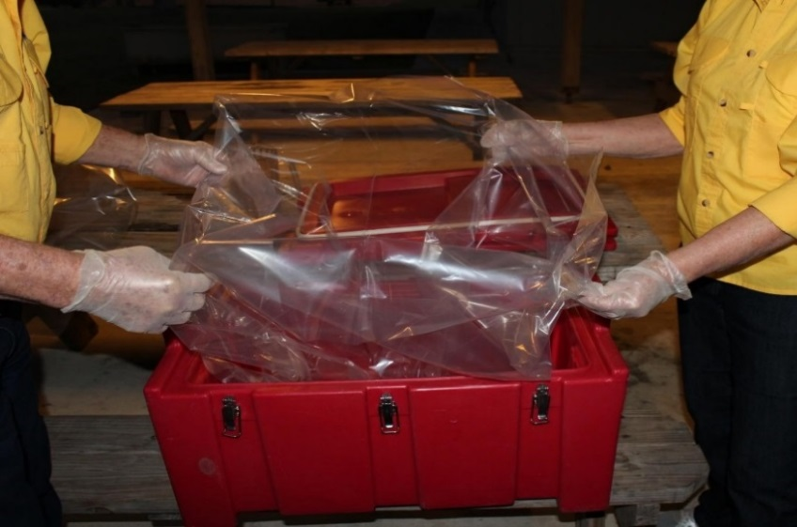

Pre-determine number of scoops that is needed for this Cambro®, and have two counters.
Do not place anything but product inside bag, Scoops of product will settle bag in
Cambro®, lift and shake bag to help settle.

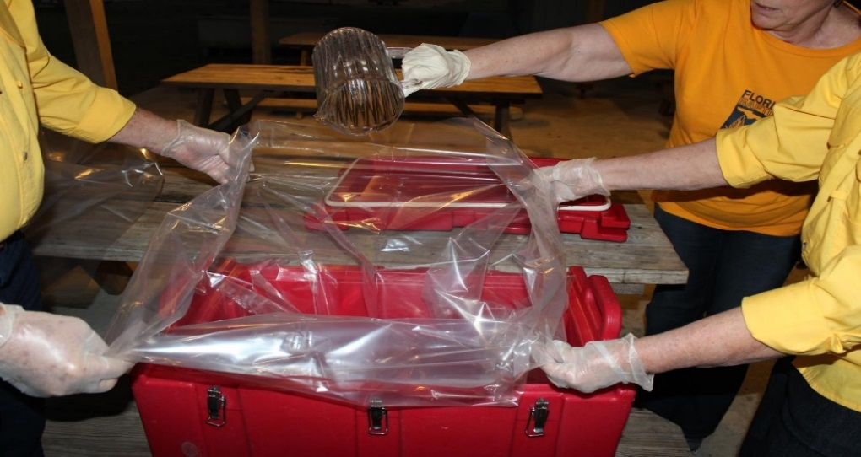

After all the product is in bag as quickly as possible, to conserve heat, lift and shake
as necessary, then begin to pull shut at top.
Begin to roll bag shut from end opposite serving lids squeezing and rolling out air as you roll.

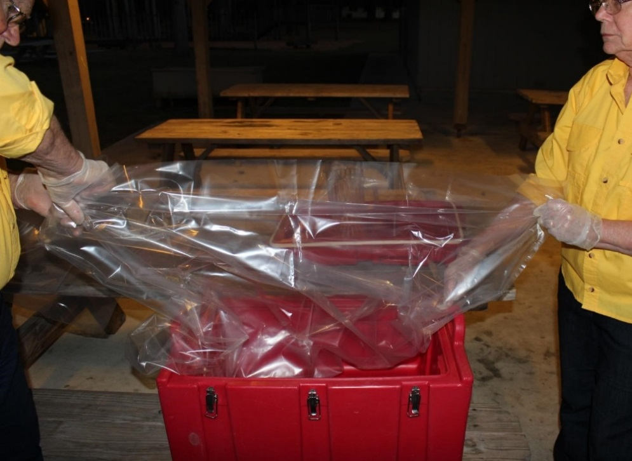

Continue to roll out air, as you tuck rolling end in upon itself.

The final roll is from the serving end, which will be tucked underhand to hold securely,
holding in heat and product. Server will lift lid and unroll to serve product.

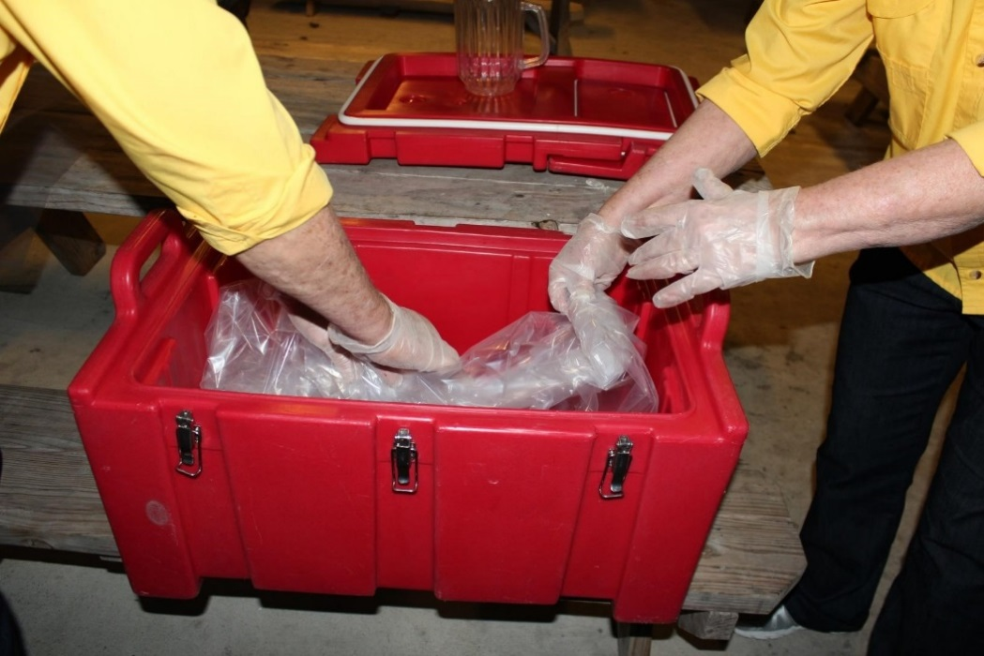

Now pick up lid which has been resting in a position not to contaminate seals.
Pick up on corners, do not touch seals.

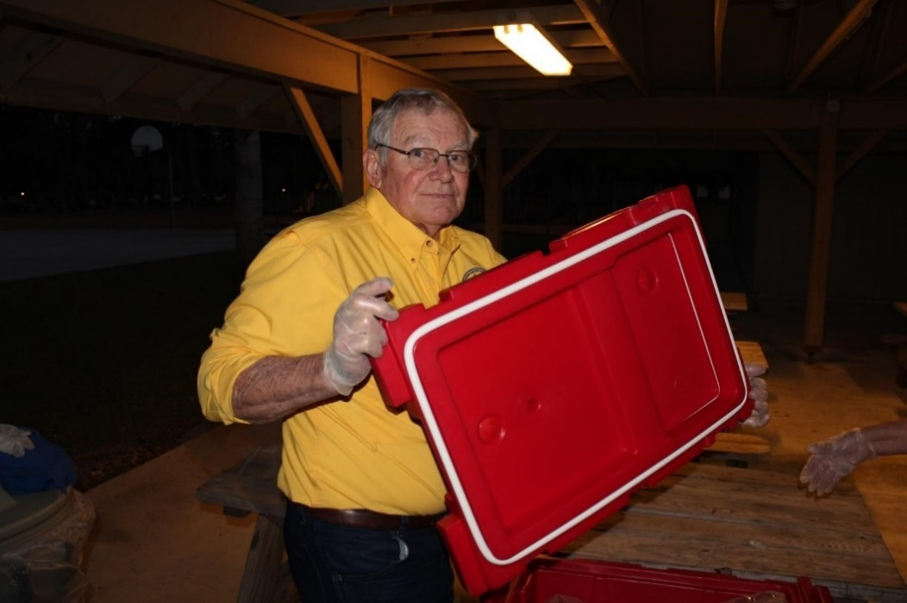

Place lid on Cambro® with serving Lid positioned over top of tucked end of roll for server to open.

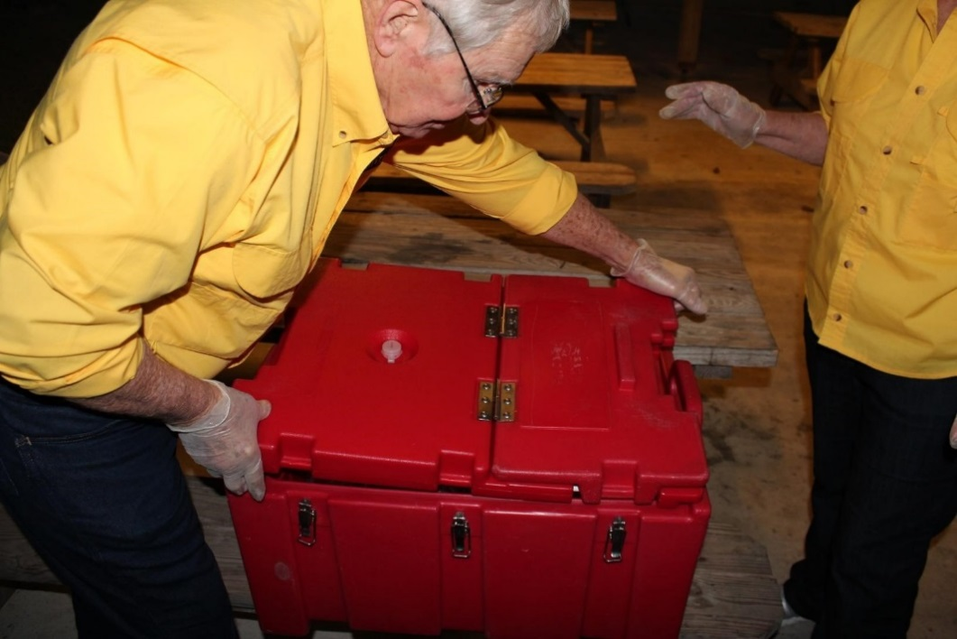

Seal all Latches, start at large end sealing 2 latches on opposite sides of Cambro® and work your way to the serving end.

  - Properly loaded, rolled, tucked and sealed Cambro® liner is the secret to SBDR feeding, and public safety.
  - Check latches of Cambro® before staging.
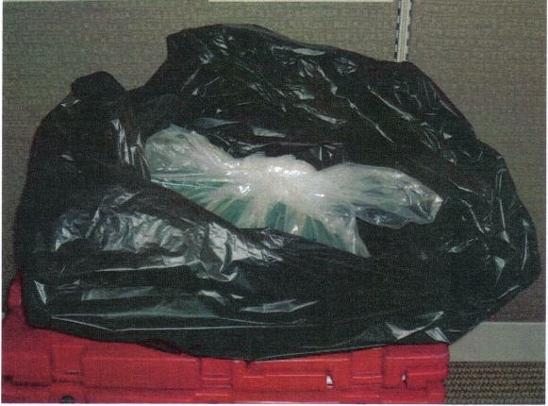

When serving is completed, remove the liner from the Cambro®, evacuate as much air from the liner as possible, gather the top of the liner and secure the open end. This liner is required to be placed in an opaque trash bag prior to disposal in a dumpster.
Southern Baptist Disaster Relief
Facility Use Agreement Between Church and SBDR

Church: _____________________________________Telephone: ______________________

Address: ____________________________________________________________________

on (month, day, year) _________________________________________ agrees to allow

Southern Baptist Disaster Relief to use the church facilities as a disaster relief operational

facility for _____________________________________________ (name of disaster response),

DR # ______________.

We have agreed to make the following available for the purposes stated below. (Note: The following are offered as examples only and are not intended to set priorities.)

Facility Purpose

All except auditorium Emergency shelter for clients/disaster survivors
Kitchen Food preparation
Dining/Fellowship Hall Food service, DAC center
Fellowship Hall Collection/distribution center
Nursery and classrooms Child care center
Classrooms/restrooms Mass care shelter/Housing for DR Volunteers

We have agreed to make the following equipment available for the disaster response for the purposes stated below. (Note: The following are offered as examples only and are not intended to set priorities.)

Equipment Purpose

Church van Transporting displaced people
Electric generator Emergency electrical service
Wheelchair Transporting injured or handicapped people

__________________________________ ____________________________
Church Representative Date

__________________________________ ____________________________
SBDR Representative Date

American Red Cross Facility Use Agreement Instructions

Facility Use Agreement Instructions
Use these instructions to successfully complete the Facility Use Agreement. This job tool provides guidance in how to properly document and sign a Facility Use Agreement. This job tool should be used in conjunction with the standards and procedures detailed in Facility Management Standards and Procedures.

Facility use agreements should be completed and signed by both the facility owner (or their property representative) and an American Red Cross authorized representative to document an agreement with a facility owner regarding the use of the facility during a disaster. Before entering into a Facility Use Agreement, you should complete the Shelter Facility Survey and determine whether or not the facility meets American Red Cross standards for that type of facility. (Pages 5-6 are for shelters only.)

In hurricane-prone areas, shelters must also meet the criteria outlined in Standards for Selecting Hurricane Evacuation Shelters (ARC 4496).

After facility has been selected, follow these steps to complete the Facility Use Agreement:

- Enter parties and facility information.
  - “Legal Notices” would be, for example, a claim made against the facility owner that is being covered under our indemnification or in the very unlikely event there is a dispute between the facility owner and American Red Cross. It is common language used in most types of facility use agreements and the purpose is to ensure that any legal issue that might arise as a result of the contractual Facility Use Agreement is sent to the appropriate contact.
  - Review “Terms and Conditions” with the property representative.
  - Occasionally, it may be necessary to modify the Facility Use Agreement template to address the property representative’s needs or specific facility situations.
  - For example, some property representatives will not be involved in food or custodial service. For these facilities, you may delete either paragraph 4 (food), paragraph 5 (custodial), or both, as appropriate.
  - To delete paragraph 4 or 5, delete electronically, and renumber the remaining paragraphs, or cross out the paragraph on a printed version and have the authorized representative of each party place his or her initials next to the deletion.
  - Please send all other requested modifications to the Disaster Logistics Center at national headquarters for approval. The Disaster Logistics Center will obtain the necessary input from subject matter experts including the Office of General Counsel. (See Section 2a below for more information on other modifications.)
  - If a facility owner seeks confirmation of American Red Cross insurance coverage, direct the owner to the Web-based Downloadable Memorandum of Insurance, where the owner can review American Red Cross insurance information.
  - See the section 2) Review and Approval of the Facility Use Agreement below before signing the Facility Use Agreement with the property representative.

- Review and approval of Facility Use Agreement.
- If the property representative wishes to alter the Facility Use Agreement, the agreement must be reviewed by Risk Management and the Office of General Counsel at national headquarters. When this happens, submit the Facility Use Agreement to Disaster Logistics Support (DLC@redcross.org) at national headquarters, who will engage Risk Management and the General Counsel. Below are common alteration requests:
- Terms of paragraph 9 (reimbursement), paragraph 10 (insurance), or paragraph 11 (indemnification) cannot be altered.
- If the facility owner wishes to use another form of contract in place of the Facility Use Agreement, the form or contract must be submitted to Disaster Logistics Support at for processing through Risk Management and/or the Office of General Counsel.
  - Once the form or contract has been approved by Risk Management and/or the Office of General Counsel, have an authorized representative (who can be a Facility Service associate) sign the Facility Use Agreement with the property representative.

- File the Facility Use Agreement with all other documentation in the Disaster Requisition Facility file. See the Facility Documentation Checklist for file requirements.
- One property representative may have more than one facility. Multiple Facility Shelter Facility Open Close Inspection forms can be attached to a single Facility Use Agreement.
  - List all facilities on the Facility Use Agreement.
  - File all applicable Facility/Shelter Opening Closing Inspection forms with their corresponding Facility Use Agreement.

- Immediately before using a facility, the Facility/Shelter Opening/Closing Inspection should be used to record any existing damage and identify any restrictions regarding the use of the facility by American Red Cross, such as restrictions related to parking, off-limits areas, etc.
- If you have any questions regarding the Facility Use Agreement, please contact Logistics at the Disaster Logistics Center at 202-303-4099 or DLC@redcross.org. For questions regarding shelters and the Facility Use Agreement, please contact the Sheltering team at Sheltering@redcross.org. The Facilities associate will either answer your questions or contact the Office of General Counsel as appropriate.

American Red Cross Facility Use Agreement

DR #: |  | Facility Name:

Parties and Premises

Owner:
Legal
name:
24-Hour Point of Contact:
Name and
title:
 | Work phone: |  |  | Cell phone/pager:
Address for Legal Notices:

American Red Cross:

Legal  name: |  | The American Red National Red Cross, a corporation under the laws of the United States
24-Hour Point of Contact:
Name and
title:
 | Work phone: |  |  | Cell phone/pager:
Address for Legal Notices:

with copies to:
The American Red National Red Cross, Office of the General Counsel,
2025 E Street, NW, Washington DC 20006
and
The American Red National Red Cross, Disaster Operations,
2025 E Street NW, Washington, DC 20006.

Building Address:

Description of Premises:

Terms and Conditions

- Use of Premises. Owner agrees to allow American Red Cross to use and occupy, on a temporary basis, the Premises described above (the “Premises”) in the Building identified above (the “Building”) to conduct emergency, disaster-related activities. The Premises may be used for any of the following purposes (both parties must initial all that apply):
 | Owner initials |  | Red Cross initials
Operations center
Client service center
Volunteer intake center
Storage of supplies
Parking of vehicles

No sheltering or lodging of clients or disaster clients/victims is permitted, except as the parties may agree in a separate written agreement.
- Term. The term of this agreement begins on the date of the last signature below and ends 30 days after written notice by either party.
- Fee. Both parties must initial the applicable statement below:
  - Owner agrees not to charge any fee in recognition of the services provided by American Red Cross to the community. Owner initials: _______ Red Cross initials: _______
  - Red Cross agrees to pay $_______ per day/week/month (circle one) for the right to use and occupy the Premises. Owner initials: _______ Red Cross initials: _______

- Conduct of American Red Cross. American Red Cross agrees to keep the Premises in good condition and promptly repair all damage to the Premises or the Building resulting from the operations of American Red Cross or reimburse Owner for the costs of repairing such damage in accordance with paragraph 6 below. American Red Cross agrees not to disrupt, adversely affect or interfere with other occupants of the Building.
- Condition of Premises and Building. Owner makes no warranty or representation about the Premises or the Building. American Red Cross accepts the same “AS IS.” Owner is under no obligation to prepare or repair the Premises or the Building for American Red Cross. The parties will jointly conduct a pre-occupancy survey of the Premises before it is turned over to American Red Cross. They will use the Facility/Shelter Opening/Closing Form, to record any existing damage or conditions. American Red Cross will exercise reasonable care while using the Premises and will make no modifications to the Premises without the Owner’s express written approval.
- Reimbursement: American Red Cross will reimburse the Owner for the following:

  - Damage to the Premises or other property of Owner, reasonable wear and tear excepted, resulting from the operations of American Red Cross. Reimbursement for damage will be based on replacement at actual cash value. American Red Cross will select from among bids from at least three reputable contractors. American Red Cross is not responsible for storm damage or other damage caused by the disaster.
  - Reasonable, actual, out-of-pocket operational costs, including the costs of the utilities indicated below, to the extent that such costs would not have been incurred but for American Red Cross’s use of the Premises (both parties must initial all utilities to be reimbursed by American Red Cross)

 | Owner initials |  | Red Cross initials
Water
Gas
Electricity
Waste Disposal

The Owner will submit any request for reimbursement to American Red Cross within 60 days after the occupancy of American Red Cross ends. Any request for reimbursement must be accompanied by supporting invoices.
- Insurance. American Red Cross shall carry insurance coverage in the amounts of at least $1,000,000 per occurrence for Commercial General Liability and Automobile Liability. American Red Cross shall also carry Workers’ Compensation coverage with statutory limits for the jurisdiction in which the premises are located and $1,000,000 in Employers” Liability.
- Indemnification. American Red Cross shall defend, hold harmless, and indemnify Owner against any legal liability, including reasonable attorney fees, in respect to bodily injury, death and property damage arising from the negligence of American Red Cross during the use of the Premises.

- Owner’s Right to Revoke for Cause. Upon reasonable prior written notice to American Red Cross, Owner may revoke the permission represented by this Agreement if American Red Cross (a) fails to pay any fee or payment required hereunder or (b) breaches any other obligation hereunder and such breach continues after written notice from Owner describing same. If the permission license is so revoked, American Red Cross shall vacate the Premises in a neat and orderly manner. Owner shall have all rights and remedies available to it under applicable law.
- Casualty or Condemnation Affecting Premises. Notwithstanding anything in this Agreement to the contrary, in the event that damage or casualty to all or a part of the Premises, this Agreement shall terminate and American Red Cross shall have no right to restoration of the Premises or to receive any compensation whatsoever.
- Legal Notice. Notice shall be deemed to have been duly given three (3) business days after having been mailed by certified or registered mail, return receipt requested, to the party’s address for Legal Notice set forth at the beginning of the Agreement, or upon receipt if delivered by hand or recognized overnight delivery service. Either party may change its address for the purpose of Legal Notice hereunder by providing the other party with notice of the new address.
- Governing Law and Binding Effect. This Agreement shall be governed by and construed under the laws of the state in which the Building is located. This Agreement shall be binding on the parties and their respective, successors, transferees and assigns.
 |  | THE AMERICAN RED NATIONAL RED CROSS
Owner (legal name) |  | (legal name)
By (signature) |  | By (signature)
Name (printed) |  | Name (printed)
Title |  | Title
Date |  | Date

WEB SEARCH

FEMA
ServSafe

ACRONYMS:

SBDR -Southern Baptist Disaster Relief
RC -American Red Cross
TSA – The Salvation Army
EOC – Emergency Operations Center

Southern Baptist Disaster Relief would like to thank the following for their contributions in updating this manual.

Dean Kiser, Oklahoma
Sarah Jo Trimble, Florida
Jim Ramey, Tennessee
Karen Smith, Kentucky
David Reynolds, Georgia
Eddie Blackmon, SBDR
Caprice Brown, RC

