Oklahoma Southern Baptist
Disaster Relief

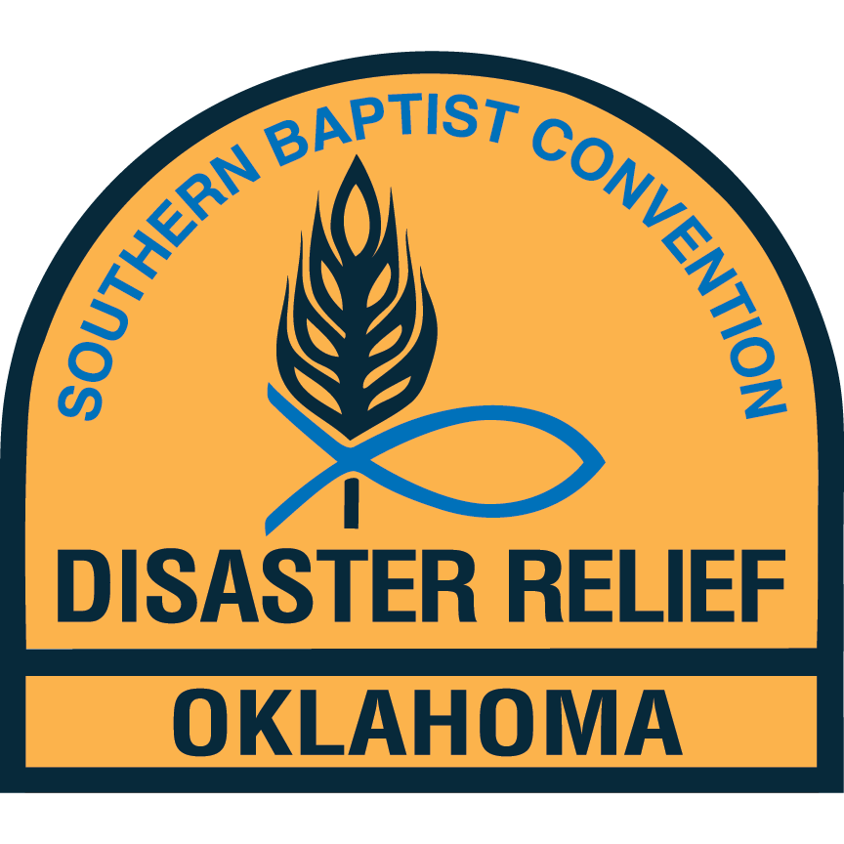

Flood and Fire
Recovery Training

Introduction

Recovery is the efforts of trained volunteers to help disaster victims prepare their home or homesite for rebuild. This manual is intended to assist in the training of these volunteers. It will not teach you everything about a disaster, but will help to give you an overview that will help prepare you for the inevitable.

Flood Recovery

Flood recovery is the cleaning of a structure to prepare it for rebuilding and habitation. This will teach you some of the safety and hazards that you will see while doing flood recovery.

PERSONAL PREPARATION
- Shots
It is recommended that everyone operating in a flood recovery operation should have a tetanus shot as recommended by their local health department. It is also recommended that individuals check with their health department about hepatitis A and B shots. When going into a foreign country, it is recommended that the volunteer have a typhoid vaccination.
- Clothing:
  - Yellow Shirts
  - Jeans or work pants
  - Boots - Hiking, work boots, or rubber boots
- The following should be on the trailer:
  - First aid kit
  - Masks
  - Latex & Latex-Free gloves
  - Work gloves
  - Safety glasses
  - Hard hats

HAZARDS

- Unseen Hazards
There are many items that are unseen after a flood including bacteria, germs, and viruses. The source of the unseen hazards may be from the following sources: human or animal waste, dead bodies (animal or human), medical waste, farm waste, fertilizers, industrial waste, and nuclear waste.
- Seen Hazards
  - Many animals and creatures have been moved from their natural habitat during a flood. It becomes necessary to watch for snakes, spiders, and other wildlife. It is also not unusual for domestic pets to be aggressive after the fright of a flood, approach with caution. Homeowners may also be seen as a hazard as they have faced the stress of the disaster and may act illogically.
  - Structural damage is also a hazard.

SITE CLEAN UP

It is necessary to expose the substructure of the home so that it may be sanitized.

- Walls
  - Remove drywall at least 12 inches above the water line or mold line (whichever is higher). This should be done in increments of 2, 4, or 8 ft.
  - Remove all insulation that has been wet
  - Remove insulated ductwork that has been wet
  - Pull all nails

- FLOORS
  - Cut carpet into manageable sizes then remove the pieces and dispose of them.
  - Cut linoleum into manageable sizes then remove the pieces and dispose of them.
  - Multiple layers of flooring should be removed and disposed of to the sub-floor.
This may be accomplished by using a carbide tip skill saw blade. Cut the flooring into narrow strips with the blade depth set above the sub-floor and remove the floor with a pry bar.

- BASEMENTS
  - Never pump out over 18 inches of water. Hydrostatic pressure in the soil behind the basement walls may cause the walls to implode.
  - Basements with dirt floors may need to be pumped out multiple times.

- KITCHENS AND BATHROOMS
  - Totally remove the cabinets if the water line is above the counter top.
  - Only solid substrate counter tops should be salvaged. All others should be disposed of.
  - Remove commode as necessary to sanitize the wall and floor.

- APPLIANCES ***NOTE: NEVER open refrigerators or freezers. Duct tape the doors closed before moving!!! ***
  - Refrigerators and freezers have elements built-in that would be hazardous to use if they have been partially under water. Appliances retained by the owner should be encouraged to take to an appliance repair shop to be disassembled and sanitized.
  - All appliances should be disposed of due to inability to properly sanitize.

- FURNITURE ***Note: Remember to show compassion when dealing with people’s personal property. Some items have great sentimental value***
  - Mattresses should be removed and disposed of.
  - Metal furniture may be sanitized and salvaged where as wood furniture is usually not salvageable.
  - Upholstered furniture should be removed and disposed of.
  - Books, pictures, and papers may be dried out and salvaged if the homeowner wishes.

- TOYS
  - Stuffed or padded toys should be disposed of. Warn the homeowner of danger in keeping these items.
  - Plastic toys that can be submerged in a disinfectant solution may be salvaged.

After all debris has been removed, pressure wash the interior. After the pressure washing is complete, sanitize with Shockwave. The structure does NOT have to be dry to spray the Shockwave.

DAILY PERSONAL PROTECTION AND HYGIENE
- If you get a scrape or a cut, GET IT CLEANED IMMEDIATELY! Any cut or scrape no matter how small can get infected. We work in very nasty conditions. Liquid band-aid is preferred to seal the wound. If liquid band-aid is not available, put plenty of antibiotic ointment on the area and cover with a bandage.
- Protect the body to prevent anything from entering through the eyes, ears, nose, or mouth.
- Use safety glasses, respirator, and two pairs of gloves. (Latex with work gloves).
- Use Tyvek suits when necessary.
- Wear waterproof rubber boots when necessary.
- Prior to eating or drinking, be sure to wash hands with antibacterial soap. Hand sanitizer should be available.
- Be extremely careful with touching your face, eyes, and body.
- Dispose of gloves and mask at the end of each day. If your gloves get a hole in them, dispose of them and get a new pair. There should be extra gloves on the trailer.
- Remove shoes/boots outside before entering the church. There should be a place set up by the door for you to set your shoes/boots on.
- When able, shower before the evening meal.

MOLD
Mold comes in all colors: Red, Brown, Yellow, Black, & White. Mold is mold no matter what the color is and mold spores can be dangerous.
- Mold Dangers - when spores are disturbed and become airborne
  - Allergic skin irritation
  - Eye irritation/infection
  - Sinus irritation/infection
  - Breathing problems
  - Headaches and/or nausea
  - Lung irritation/infection
- Personal Protection
  - Boots, jeans, long sleeve shirt.
  - Disposable gloves
  - Disposable mask (N95 or mask w/cartridges)
  - Tyvek suit (if needed)
  - Goggles
  - Dispose of the disposable
  - Sanitize the sanitizable
  - Launder all clothes including your hat
  - DO NOT: Rub your eyes, touch your nose, or scratch your ears.

==================================================================

TEMPORARY ROOFING
(Blue Tarps)

Tarping is a temporary repair to a home or structure designed to prevent further damage until permanent repairs can be made.

SAFETY

- Always use extreme caution when working on a roof.
- Be aware of weather conditions. Do not work on roofs that are wet or have snow/ice on them.
- Safety lines should be used on all roofs except flat roofs and roofs with a 4:12 pitch or less.
- Only fiberglass or wood ladders should be used. No metal or other electrically conductive material ladders should be used.
- Do not attempt to nail temporary roofing into tile, concrete, or other similar roofing material.
- Fully check the inside and outside of the structure to determine that it is safe to work on the roof.
- Roof and ground teams shall wear work gloves, eye protection, knee pads, sturdy work boots, and wide brimmed hard hats that protect face, ears, and neck
- Sunscreen should be applied 10-15 minutes before climbing the ladder to the roof. Make sure hands are not greasy before climbing the ladder.
- All safety equipment recommended by hand or power tool manufacturers should be worn while operating these tools/equipment.
- Never carry tarps, equipment, or supplies up a ladder. These materials should be lifted to the roof by a rope system or other material lift system.
- Locate and identify all electrical, TV, telephone, and/or other wires in the area where work is to be performed. Develop a plan to complete work without coming into contact with these wires. ALWAYS ASSUME WIRES ARE ELECTRICAL AND ARE “LIVE” WIRES!

BASIC PROCEDURES

- Only tarp what is necessary. Do not tarp an entire roof if only a small area is damaged.
- Ladders shall be secure before climbing. A team member should always be at the foot of the ladder to steady the ladder, watch for safety concerns, and keep others clear of the ladder while workers are climbing up or down.
- Allow for overlap of tarps along deck and over the ridge when measuring.
- Remove any loose debris or materials before beginning.
- Start at the far side and tarp towards the ladder.
- Furring strips are placed to secure the blue tarp, channel water flow, and support tarp over a large opening.
- Tarps should overlap downhill a minimum of 4 inches.
- Cut out for vents and pipes and seal with approved tape.
- Mobile homes and homes with tile roofs may be repaired by utilizing tarps with grommets and ropes; not by securing with nails.
- Nails are to be used with wood desks or composition roofs and screws for metal decks.
- When finished, take the time to make sure there are no nails or screws left on the roof, in the yard, or on the sidewalks and driveways.

FIRE RECOVERY

The procedure for cleanup after a fire will be governed to a great extent by local regulations. Property owners and our volunteers will have to meet all regulations and will be responsible for such.

PROCEDURES
- Separate as much scrap metal as possible from the ash.
- Bricks, concrete blocks, and cement foundation piers will normally be greatly weakened by the heat of a fire. They may be moved by hand, wheelbarrow, or skid steer to a designated area/bin.
- Sift through the ash in designated locations to find valuables. Volunteers should be alert for possible salvage items throughout the whole cleanup process and take any such items to a designated location. Let the property owner decide what is to be disposed of and what is to be kept.
- If the structure was a mobile home or trailer, either a chop saw may be used to cut up the frame so it can be moved to the metal pile/bin. A spotter should always be used to not only assist the person using the equipment, but to make sure other volunteers or people present stay a safe distance from the cutting.
- After the larger debris has been removed, in most cases, a skid steer will be used to remove the remaining debris and ash from the building slab or immediate building site. If there is no skid steer or the debris is not accessible to the skid steer, volunteers will need to shovel ash into a wheelbarrow and manually remove the ash/debris.
- If the site is a slab foundation, volunteers will finish up by sweeping the slab.

HEALTH AND SAFETY CONCERNS
- Footwear - Volunteers are to wear solid sole shoes/boots. No tennis shoes.
- Face masks are recommended when working in ash.
- Heavy work gloves are recommended
- Ear plugs are advisable if the volunteer is working around power tools or in the vicinity of loud noises.
- Safety glasses or goggles may be necessary at times.
- Always be aware of where heavy equipment is.
- Take breaks as necessary. Drink plenty of water.
- Lifting should always be done in a way that protects the back from strain and other injury. To lift safely, bend the knees and squat, keep the load close to the body, keep the back straight, push up with the legs. Get someone to help with heavy objects.
- Use hand sanitizer before handling food.
- Do not open refrigerators/freezers or puncture sealed cans. Secure doors of appliances with duct tape.
- Do NOT touch any electrical lines or cables until it has been verified that they are safe.

Always look out for the safety of yourself and other volunteers. If you see a safety concern, talk with your Bluecap.

