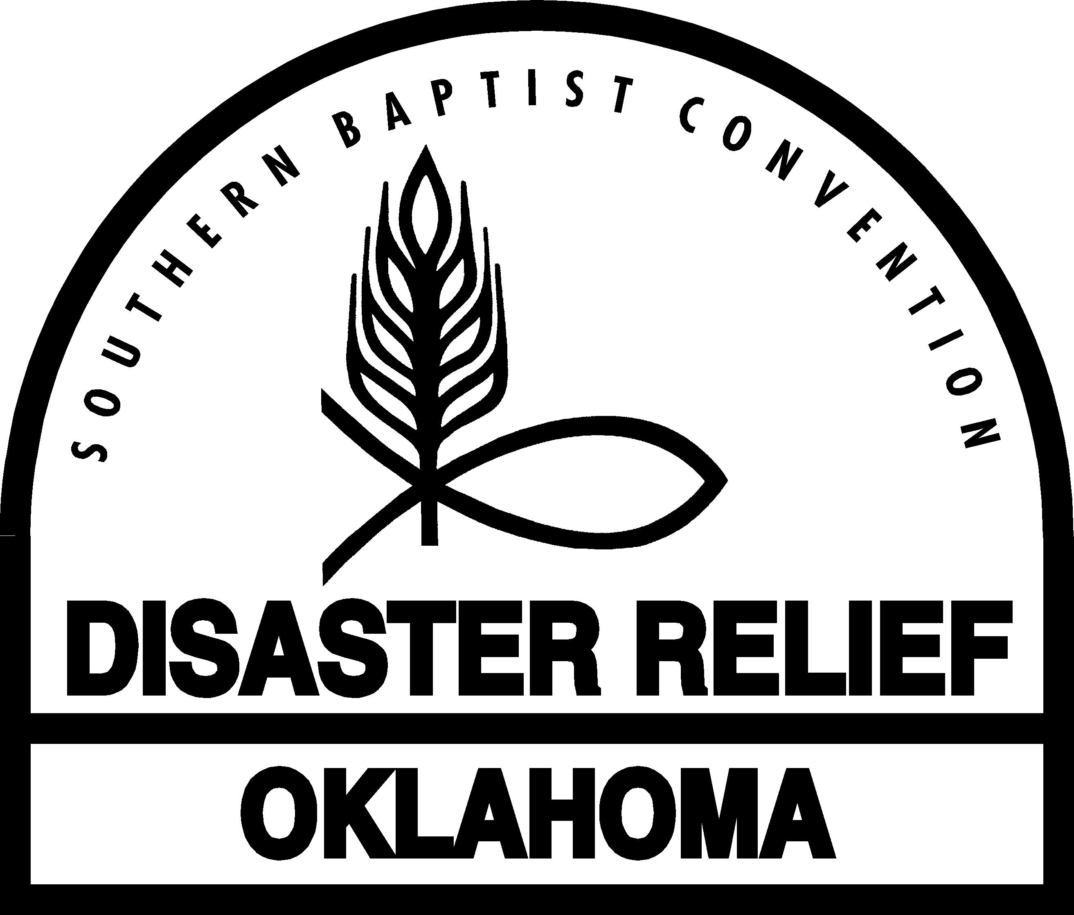
REGISTRATION
DISASTER RELIEF MINISTRY
Please Print Clearly
Are you an active member of a Southern Baptist Church or Baptist Collegiate Ministry (BCM) and at least age 18 ? YES NO (circle one)

Is this your first time to attend Disaster Relief training? YES NO (circle one)

Legal Name: Last _________________________________ First _________________________________

Mr. Mrs. Ms. Miss (circle one) Preferred name _____________________________

Home phone (___________)_________________________________________

Mailing address: Street or P O Box ________________________________________________________

Mailing address: City/Town _______________________________________ Zip Code _______________

Zone: Central NE NW SE SW (circle one) (Central is Cleveland, McClain & Oklahoma
Counties. I-35 & I-40 mark NE, NW, SE & SW)

Church/BCM_____________________________________City/Town_______________________________

Association ____________________________________________________________________________

Your e-mail address ______________________________________@______________________________

Work phone (__________)____________________________________________

Cell phone (__________)____________________________________________

Date of Birth ______________________________________________________

Beneficiary’s name _________________________________________________

Spouse’s name _____________________________________________________

Spouse’s day phone (__________)______________________________________

Today’s date ____________________ Location of today’s training _______________________________

Do you have a CDL license? YES NO (circle one) CDL Class______ CDL Endorsements_________

What were you trained in today? ____________________________________________________________

In which one of the Disaster Relief ministries that you were trained in today do you want to be called to serve
first, for example, Feeding? _____________________________________________ (Please list only one.)

Please read, sign, and date the Volunteer Agreement on the reverse side of this page and, after you have completed all of your training today, bring this form to the Registration Desk.

Was issued a Disaster Relief Cap __ Signed Volunteer Agreement __

8-14-14 This form can be found at www.bgco.org/drresources.

