INSTRUCTIONS FOR DISASTER RELIEF
ID BADGE PICTURES

1. NO HATS. BADGES WILL NOT BE MADE FOR INDIVIDUALS WEARING HATS IN PHOTOS

2. BE AWARE OF BACKGROUND – preferably white with nothing on the wall.

3. MAKE SURE THE LEGAL NAME CAN BE READ AND NEEDS TO BE SHOWN IN THE PICTURE. This needs to be completed by someone who can print legibly, printing the individual’s legal name.
If legal name is a common nickname, please note name verified.

4. The person needing an ID badge should print his or her LEGAL name, preferred first NAME and mailing address on the sign-in sheet. Please make sure addresses are legible and complete, including ZIP codes. The badges will be mailed to each individual’s home upon completion.

5. Hold name below the chin, showing part of the neck. Take the picture, capturing from the name up. (Be sure and get all of the name and the top of the head).

6. When you have finished, save photos to a CD, flash drive or camera card and forward, along with the Badge Sign-In Sheet, to:
BGCO Partnership & Volunteer Missions
3800 N. May Ave., OKC, OK 73112.
Please keep a copy of the photos until the badges have been completed.

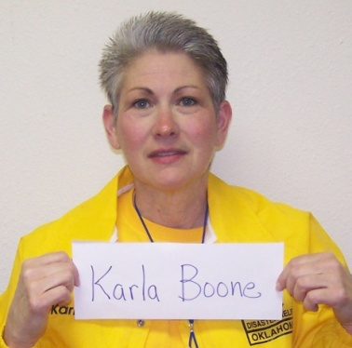
Below is an example of how the picture should look. Please have name on one line. Print with BOLD marker.

5-7-13 This form can be found at www.bgco.org/drresources. (Instructions for ID Badge Photos)

